Electron/Positron Identification

William Brandon Martin

Department of Chemistry and Physics, Erskine College, Due West, SC, 29639

Abstract

This electron/positron identification variable summary will check our understanding of these particles’ behavior in the isolated Radiative Bhabha environment versus the high-density hadronic environment of the CLEO detector.

Introduction

Electron/Positron Identification is a very important part of High Energy Physics because so many of the decay-born particles are these common leptons. Electrons and positrons behave almost the same way in the CLEO II detector, so for the remainder of this paper the general term electron will refer to both simultaneously. We use several variables to help distinguish these leptons from other particles, dE/dx, which is the energy lost per distance traveled in the drift chamber, the dimensions and divergence of the shower in the crystal calorimeter. These variables allow us to distinguish particles by the individual signature each particle leaves in the detectors. To examine these properties, we will compare an isolated track with the same track if it were embedded in an high density hadronic event. Studying electrons in this manner should aid our understanding of how these particles behave in CLEO II.

dE/dx Information

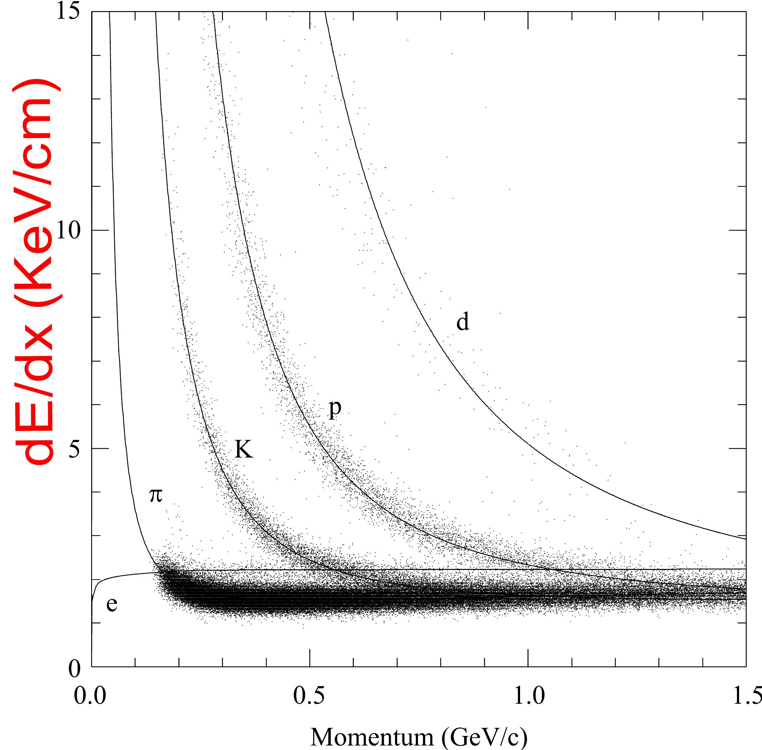
Using the valuable information in Figure 1, we can create a reference that compares the expected value for dE/dx as a function of momentum. We define this reference, SGELDI, as (dE/dX_{measured}(p)-dE/dx_{expected}(p) )/σ, where σ normalizes the distribution.

Figure 1 shows how Electrons Pions, Kaons, Protons, Deuterons lose energy as a funcion of momentum in the CLEO II detector.

Figure 2 shows the means and widths of SGELDI for electrons in radiative Bhabha events and for the same electons after embedding into hadronic events. The pre-embedded plots have the lowest mean in the momentum range around 1.5 GeV. The momentum bins on either side of 1.5 GeV have a little bit higher mean, but all of them staying below 0.18. After embedding, the plots change only small amounts indicating this variable is not heavily biased by the embedding. When we actually compare the hadronic particles to the isolated ones, we find that SGELDI is not biased very much by embedding. The means of these core distribution fall between -0.004 and 0.01. The tail distributions means fall between 0.06 and 0.01 so on average the SGELDI stays very close to its original value. When considering the Post-Pre statistics approximately 1.18% of the particle’s SGELDI changed by more than 3 core deviations. With many more particles flying around in the detector, the tracking system most likely becomes confused and mix the energy given off from other particles in the detector with the particles in question.
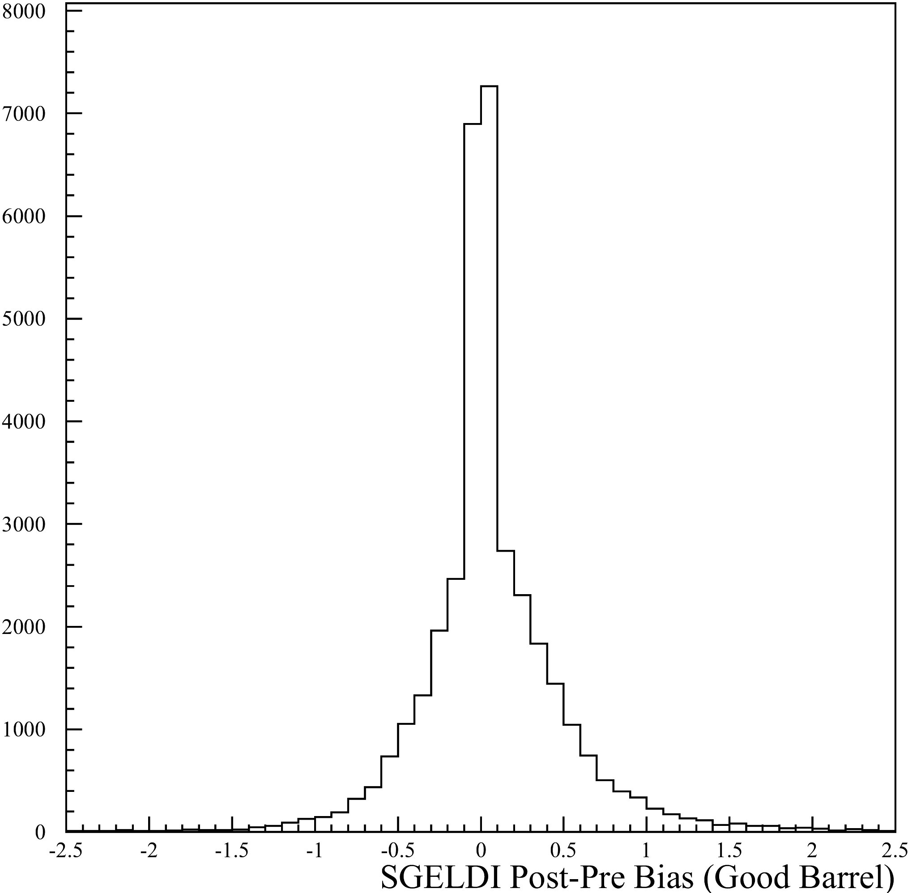
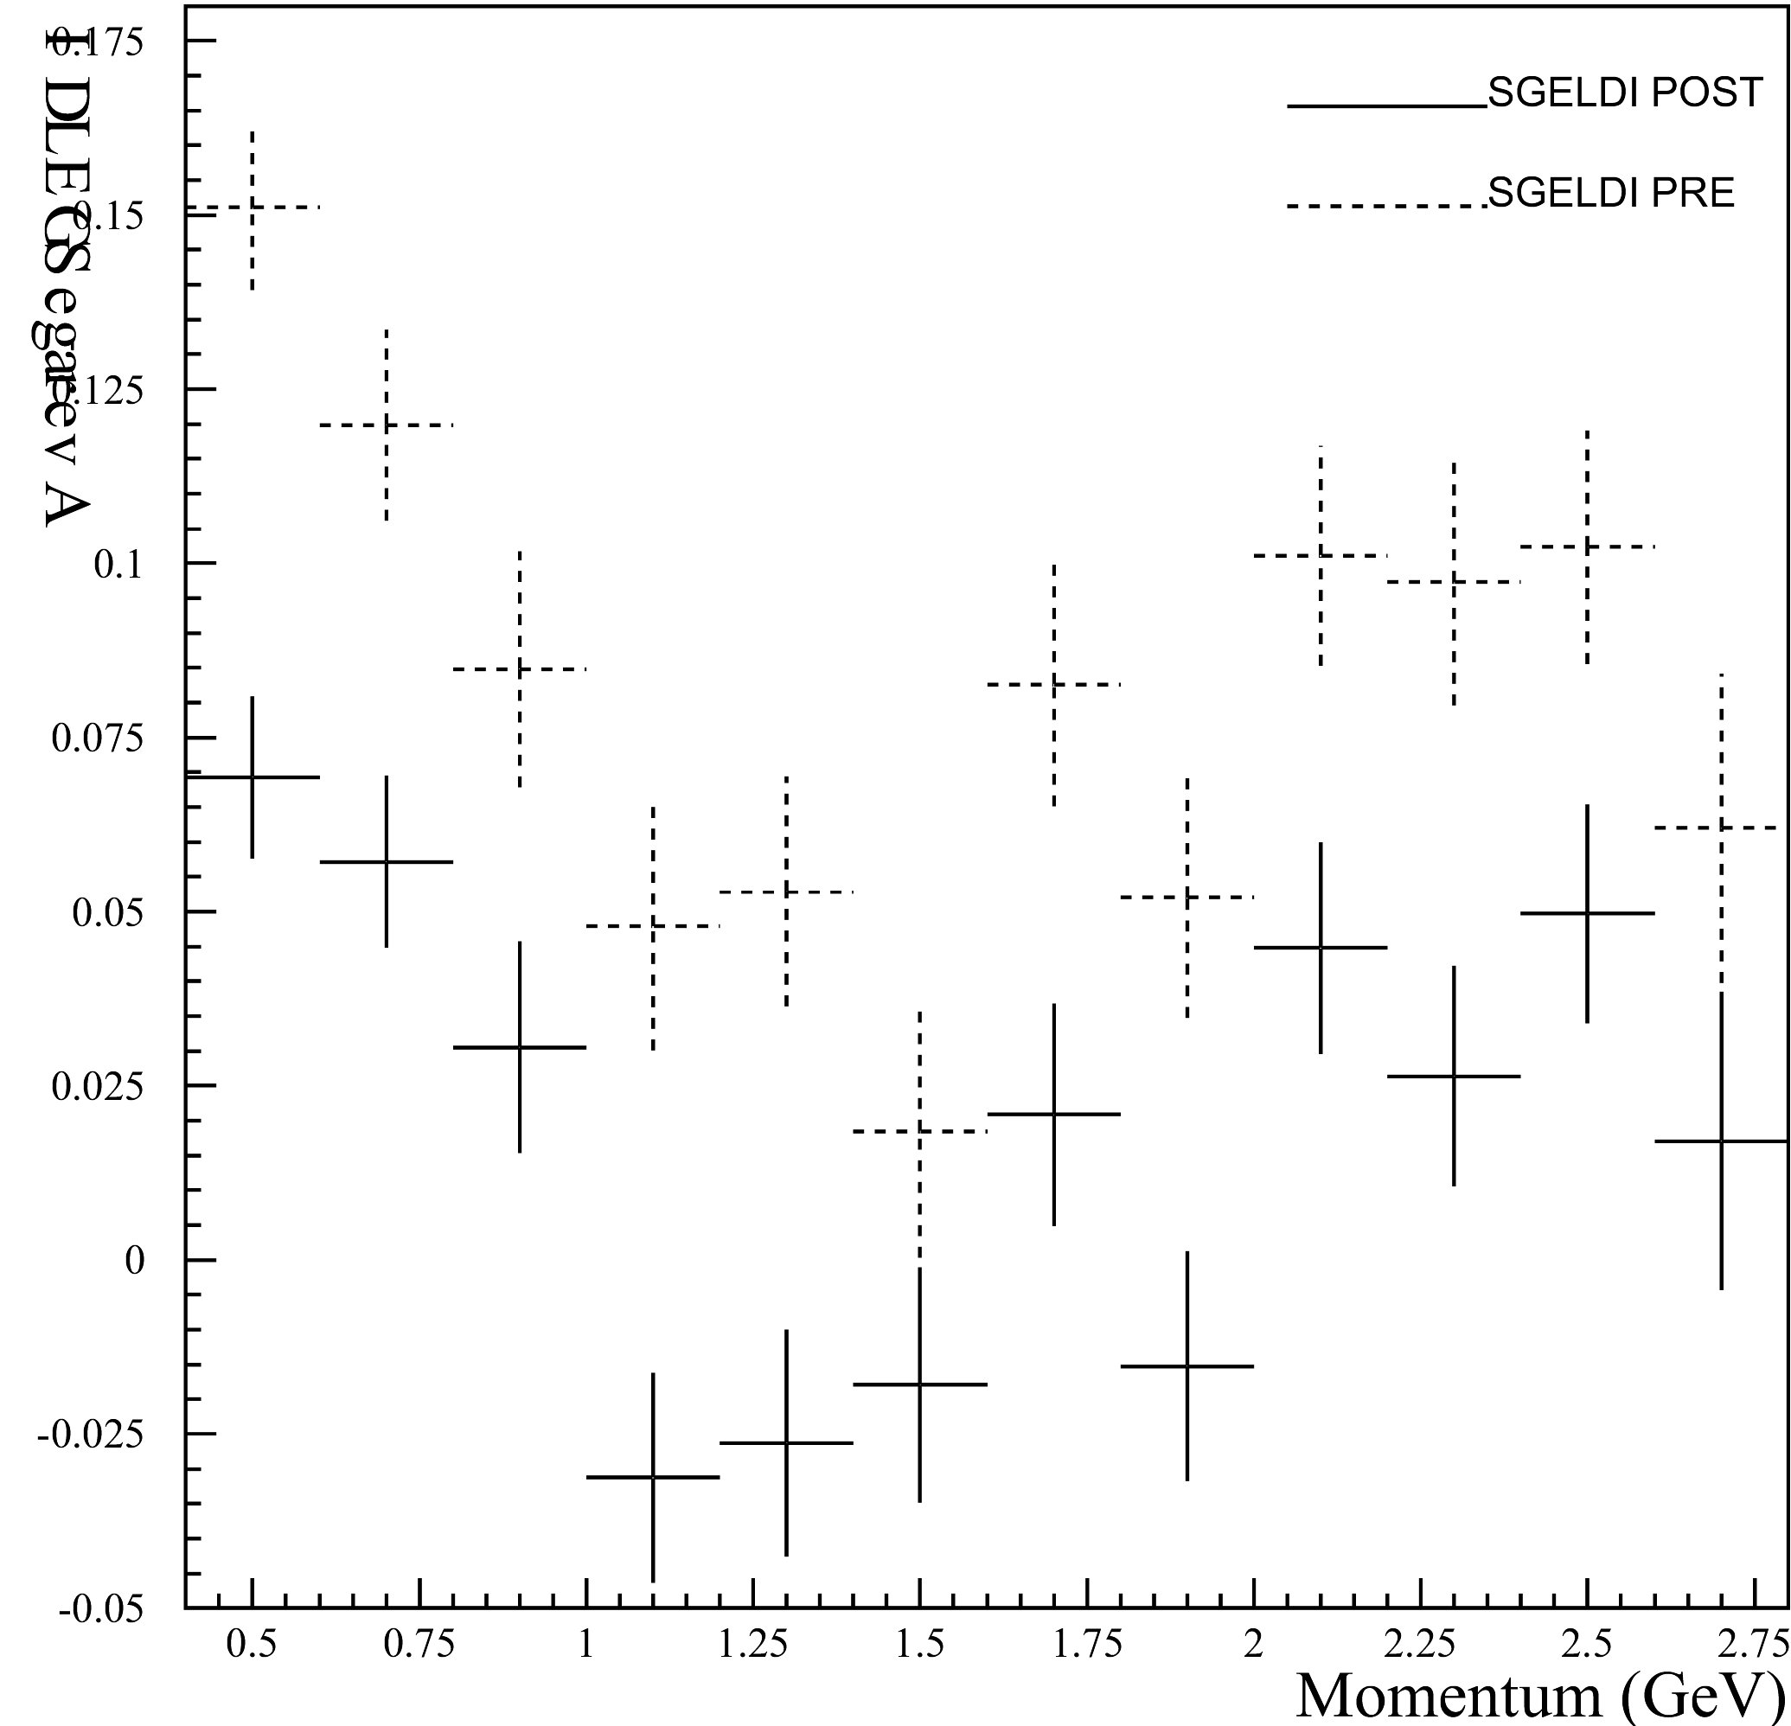
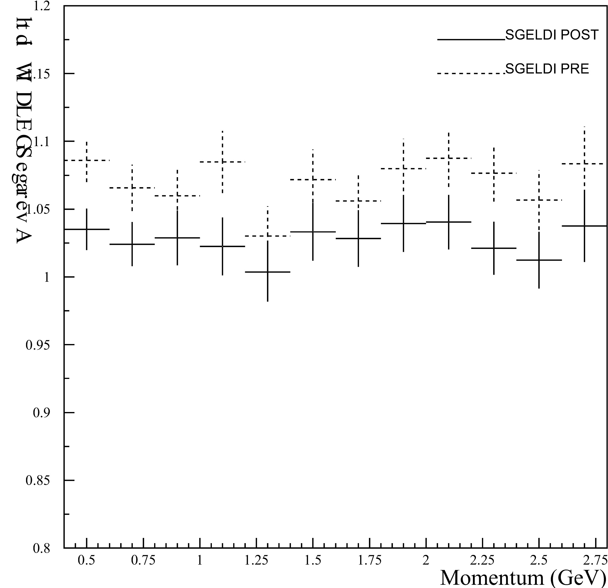
Figure 2 shows the very stable properties of SGELDI

RMS Shower Width
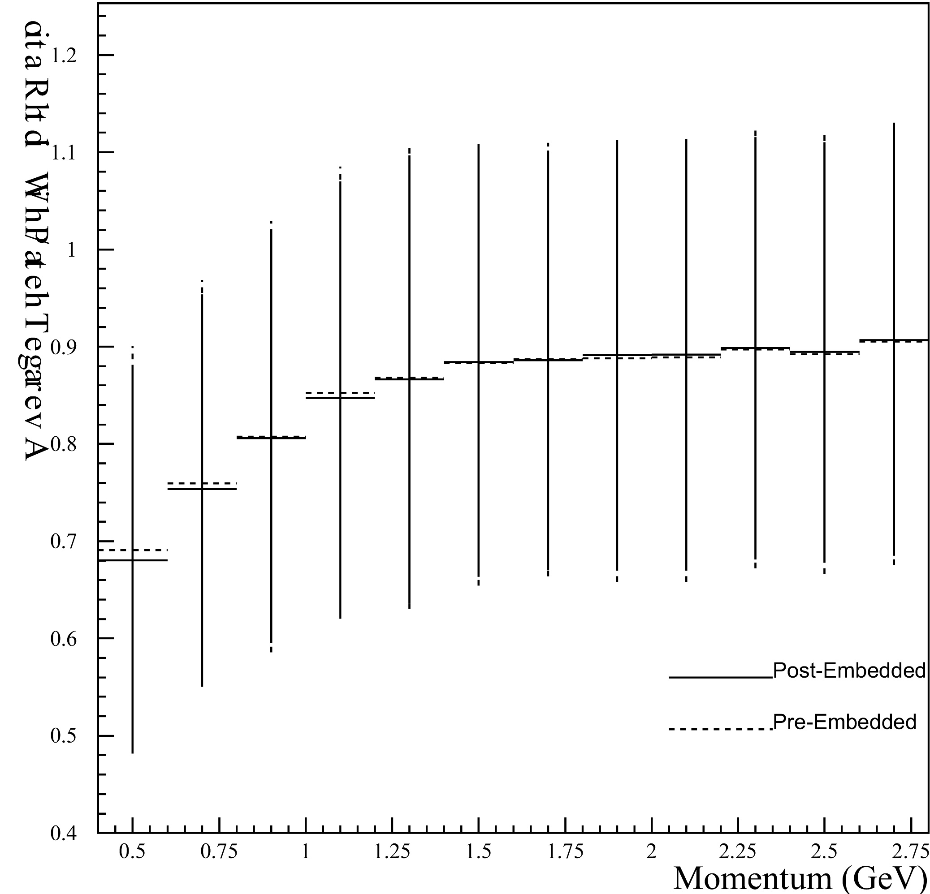
Another distinguishing property of electrons is the shower they make in the Crystal Calorimeter. The electron typically has a very narrow shower, but that may be skewed by momentum. The lower momentum tracks will actually have more momentum in the φ-direction which will cause the shower to go into the crystals sideways. This will distort the shower slightly by elongating the shower in the φ-direction. We can see this trend in Figure 4 as the ratio of the θ-width/φ-width approaches a certain asymptotic value we expect with a stiff shower.
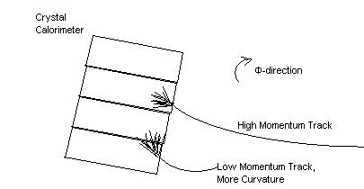
Figure 4

Embedding biases about 4.00% of the tracks. This statistic indicates that these variables are fairly stable for identifying electrons.

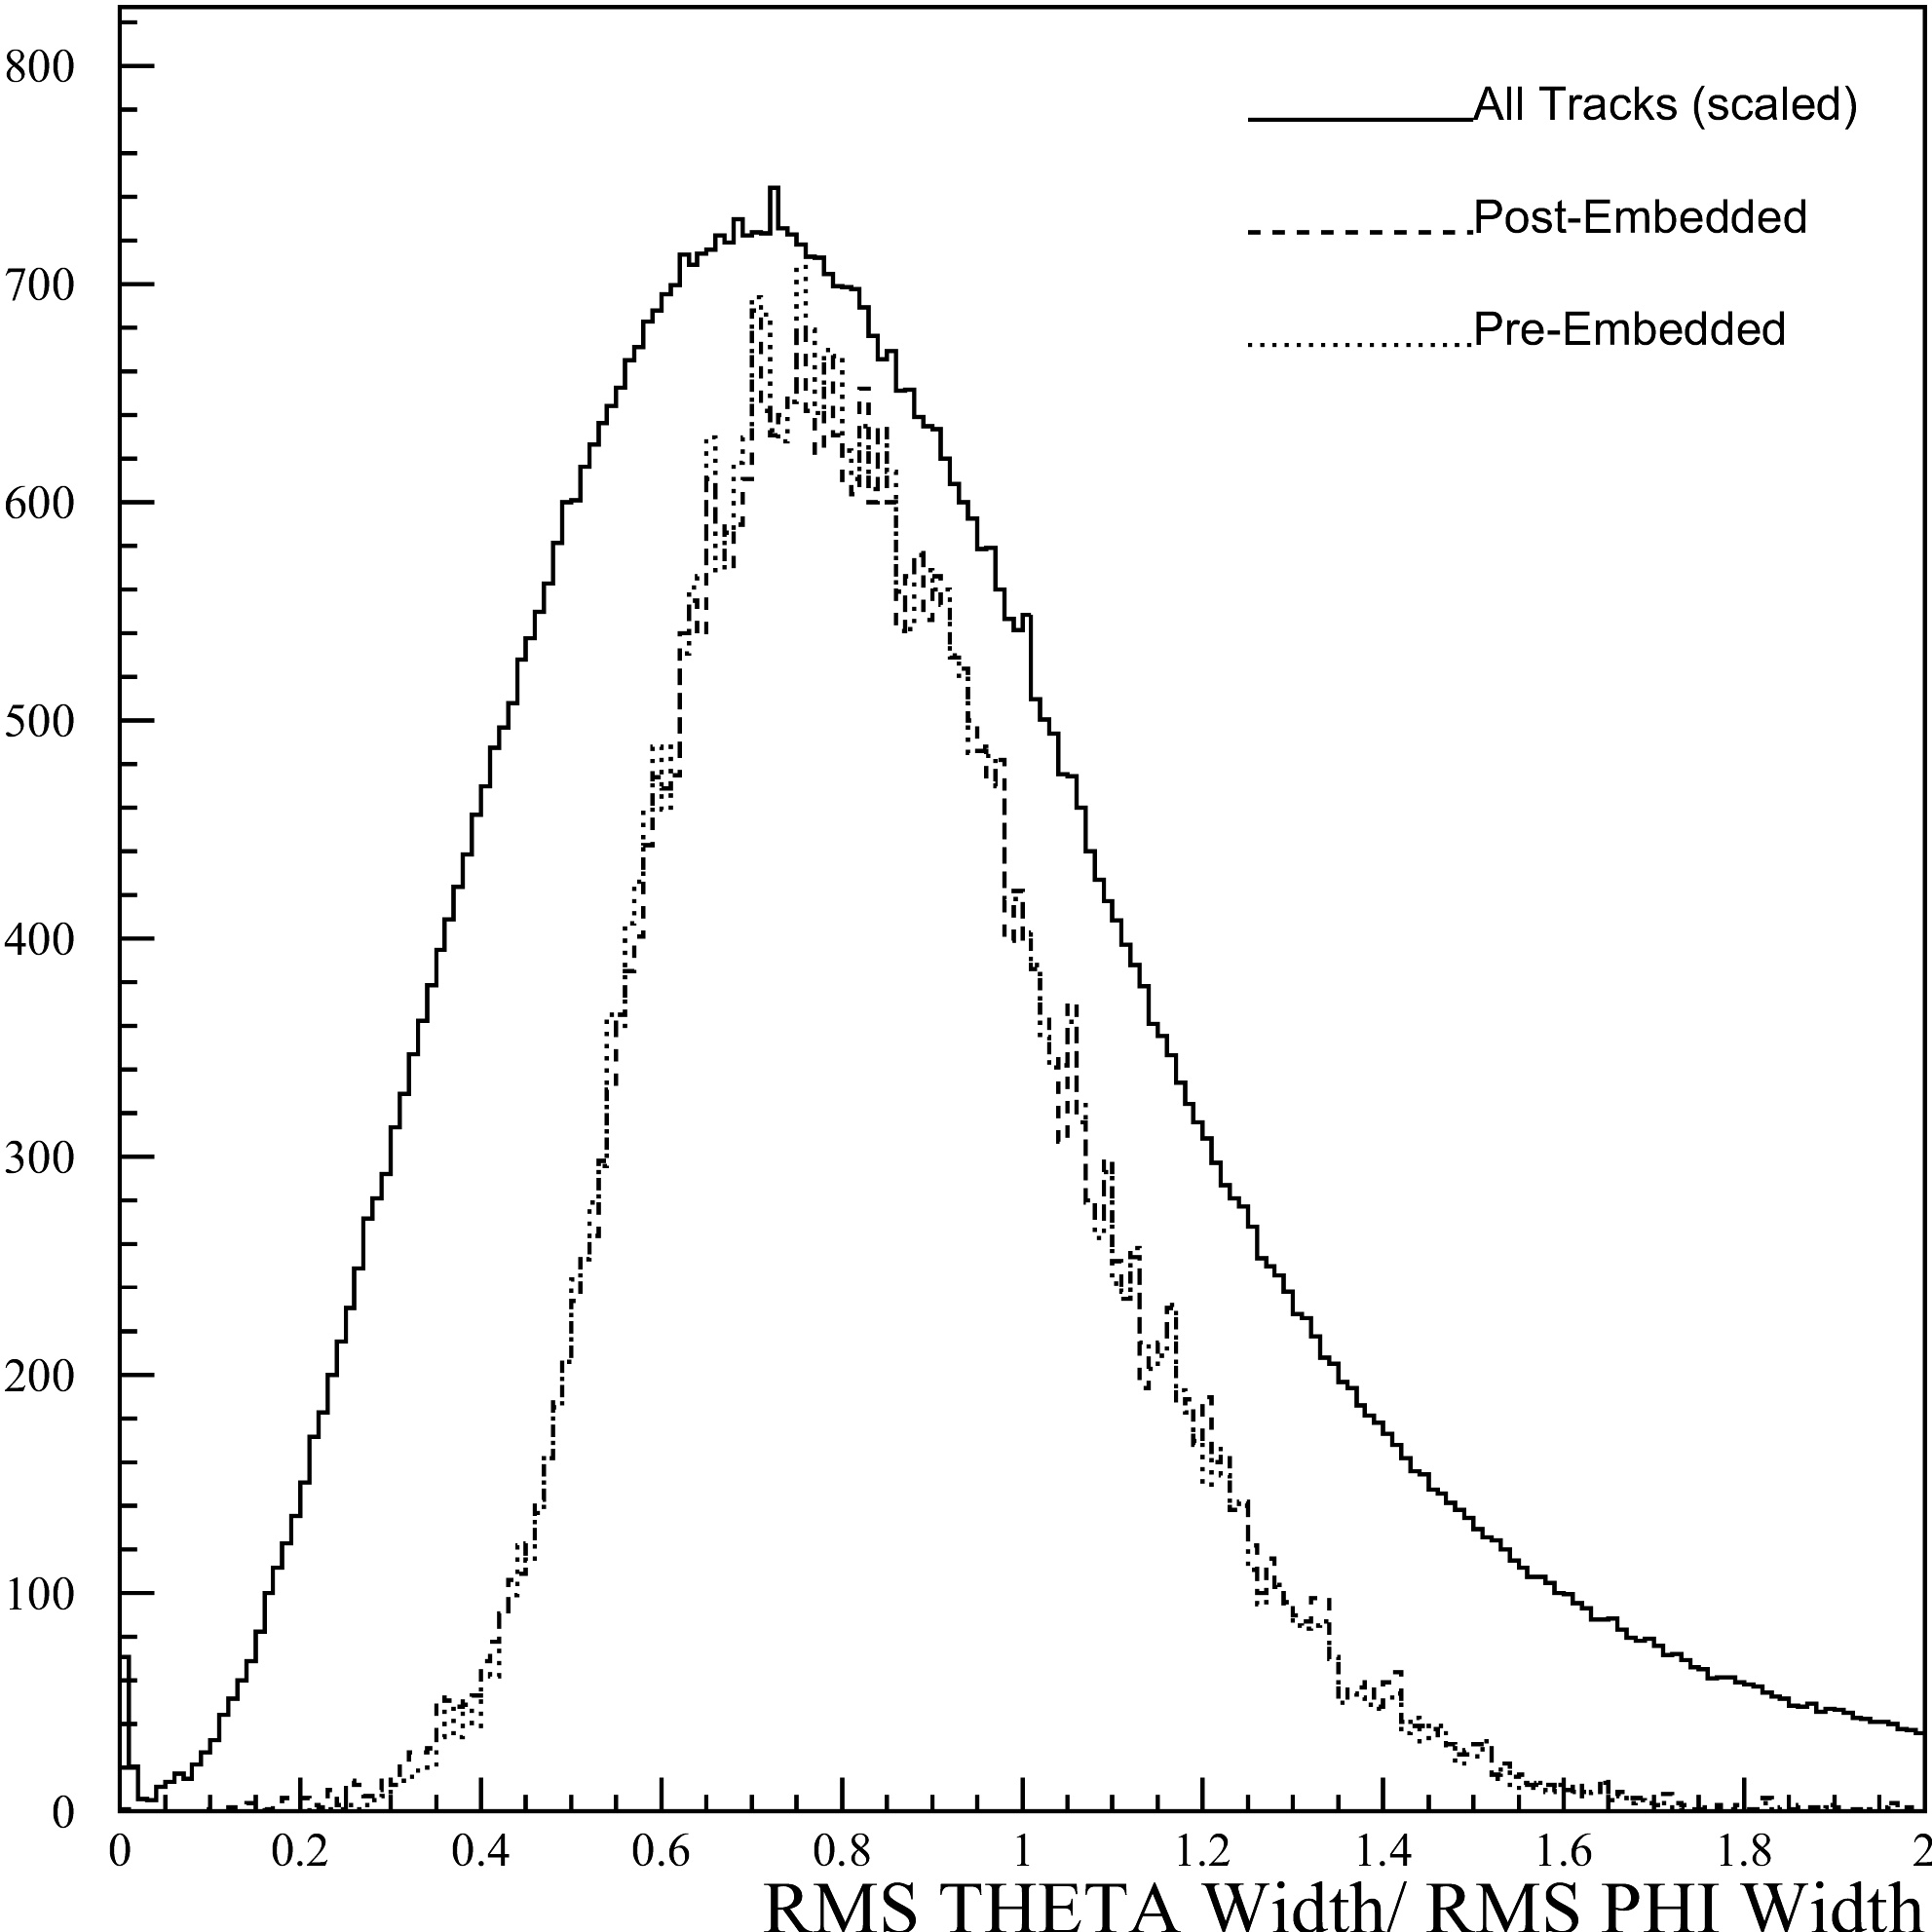
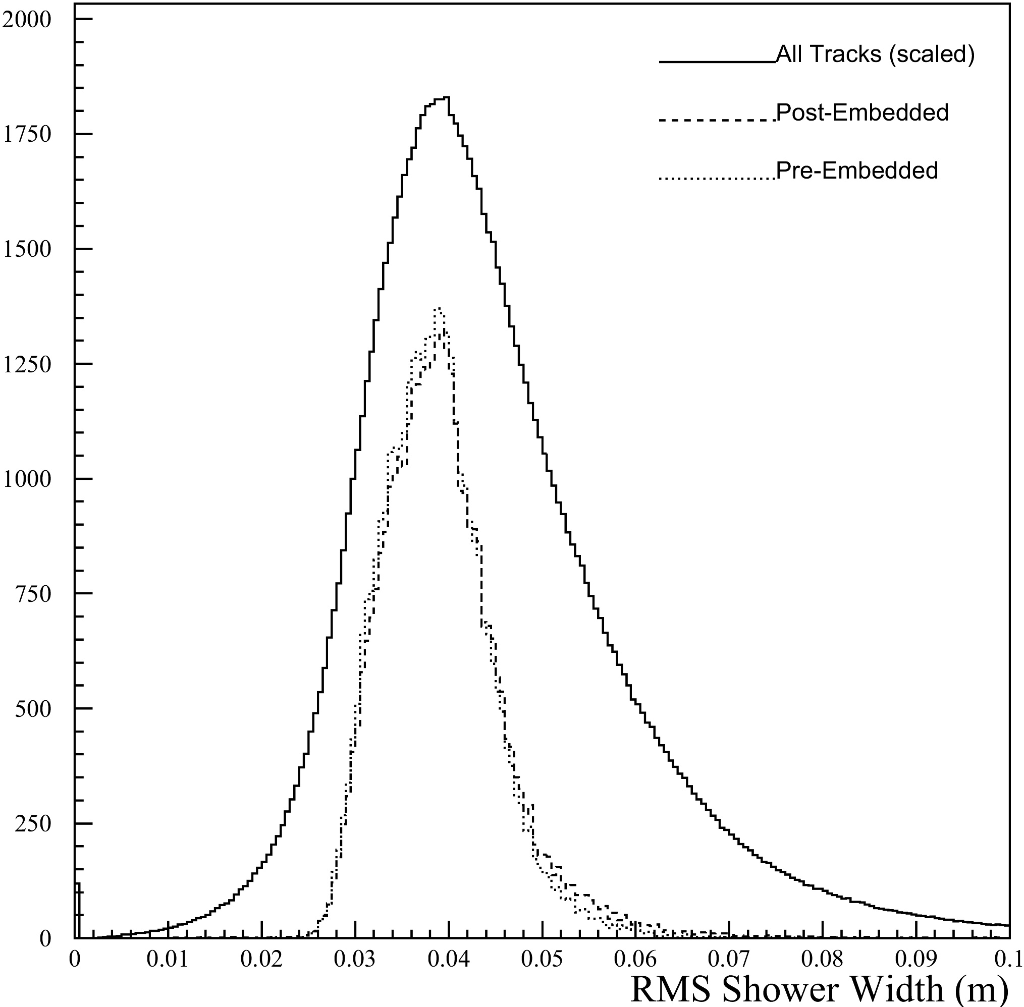
Figure 5 highlights the various properties of the shower dimensions.

E9/E25
E9/E25 is the ratio of energy in the calorimeter at a square of 3x3 crystals to a square of 5x5 crystals. These variables look into the divergence of the shower in the calorimeter. The highest value we can expect for this variable with any particle creating the shower is one, since all energy at the 3x3 level should still be there in 5x5 level. Occasionally showers will overlap and confuse the matching system. That is where the difference between two variables LPSH4 and LPSH5 enters into play. If two showers overlap, LPSH4 uses the combined energy, but LPSH5 handles the shared part shower by adding the fractional parts to the showers according to their respective sizes. These values are still very close, but if they do differ, Shower Shape 5 tends to be bigger because it has cleaned up the shower in the twenty-five crystal square, thus making the ratio bigger.
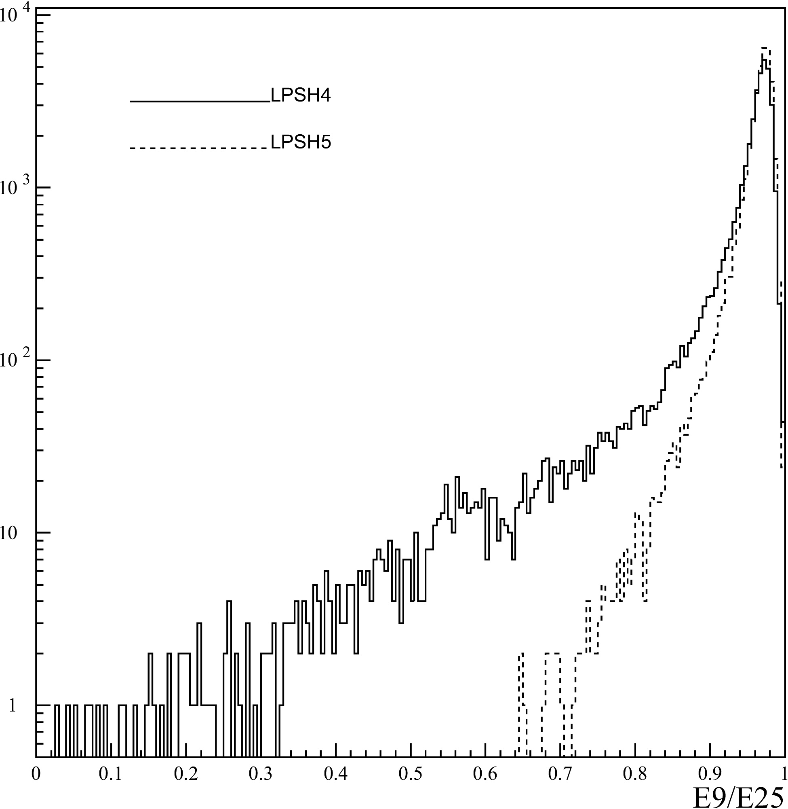
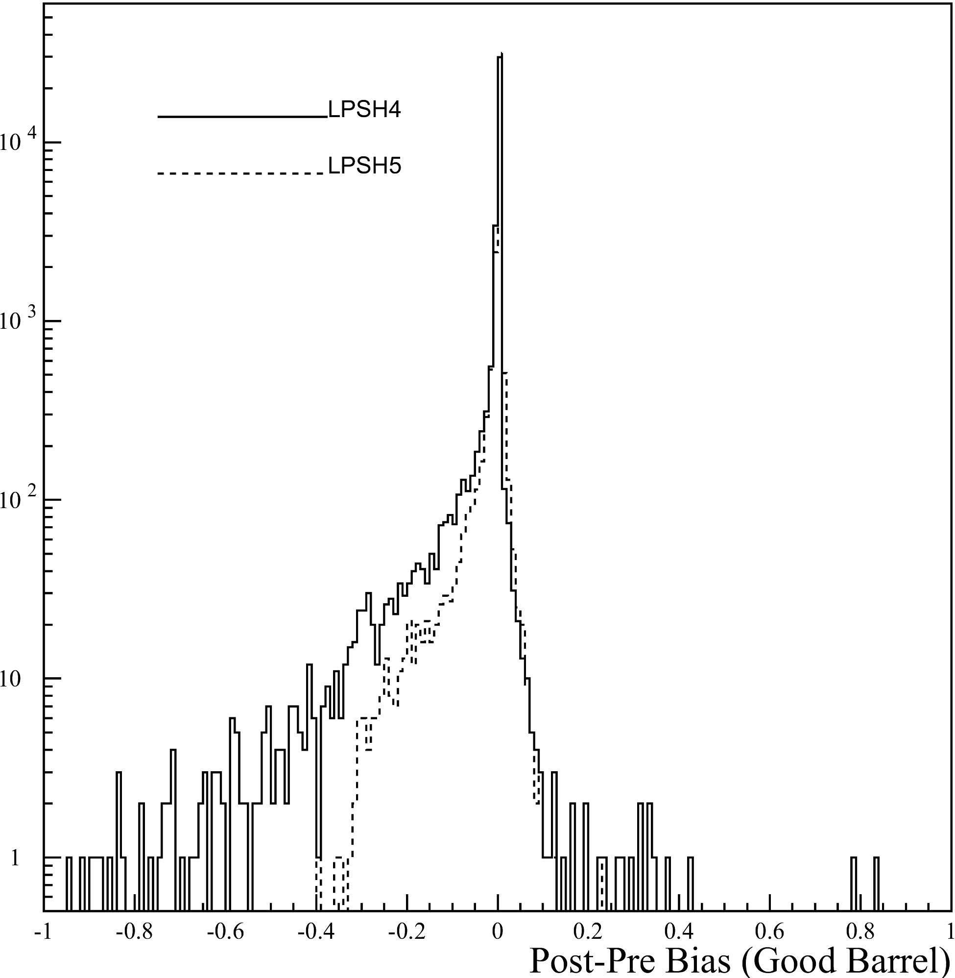
Figure 6 demonstrates the slight difference between LPSH4 and LPSH5

There is a trend that the higher momenta will again behave more predictably because of the straighter trajectory of the particles. The higher momentum bins also tend to have a better bias rate as indicated by the Post-Pre plots being much cleaner in the higher momentum bins. This is interesting because we can tell that this will not help us as much identifying low momentum particles(Figure 4). LPSH 4 has a bias rate of about 1.91%, while LPSH5 has a slightly better bias rate of 1.46%. These changes are most likely a result of other showers in the event mixing with the original shower.
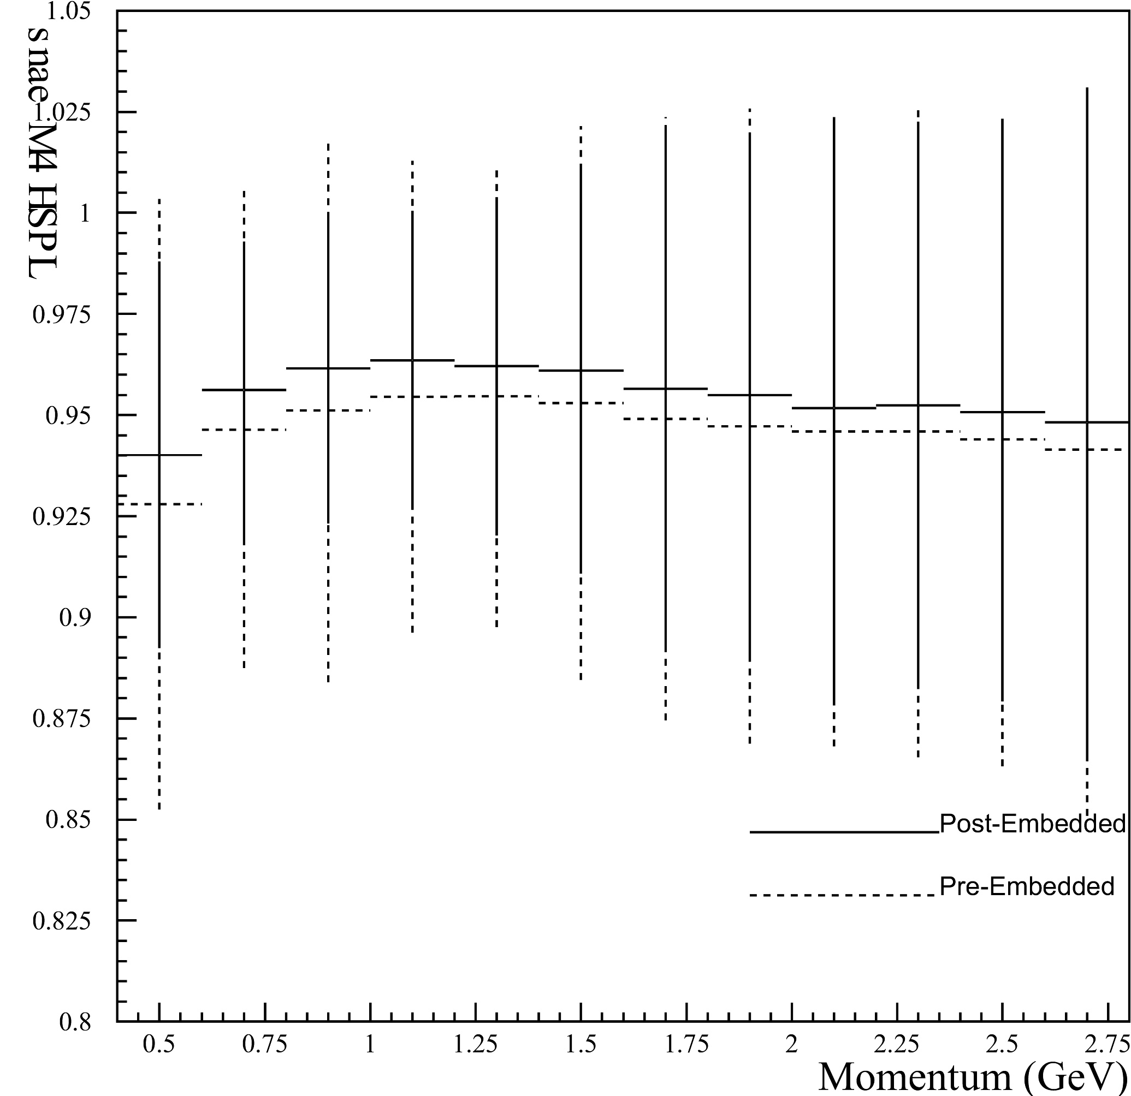
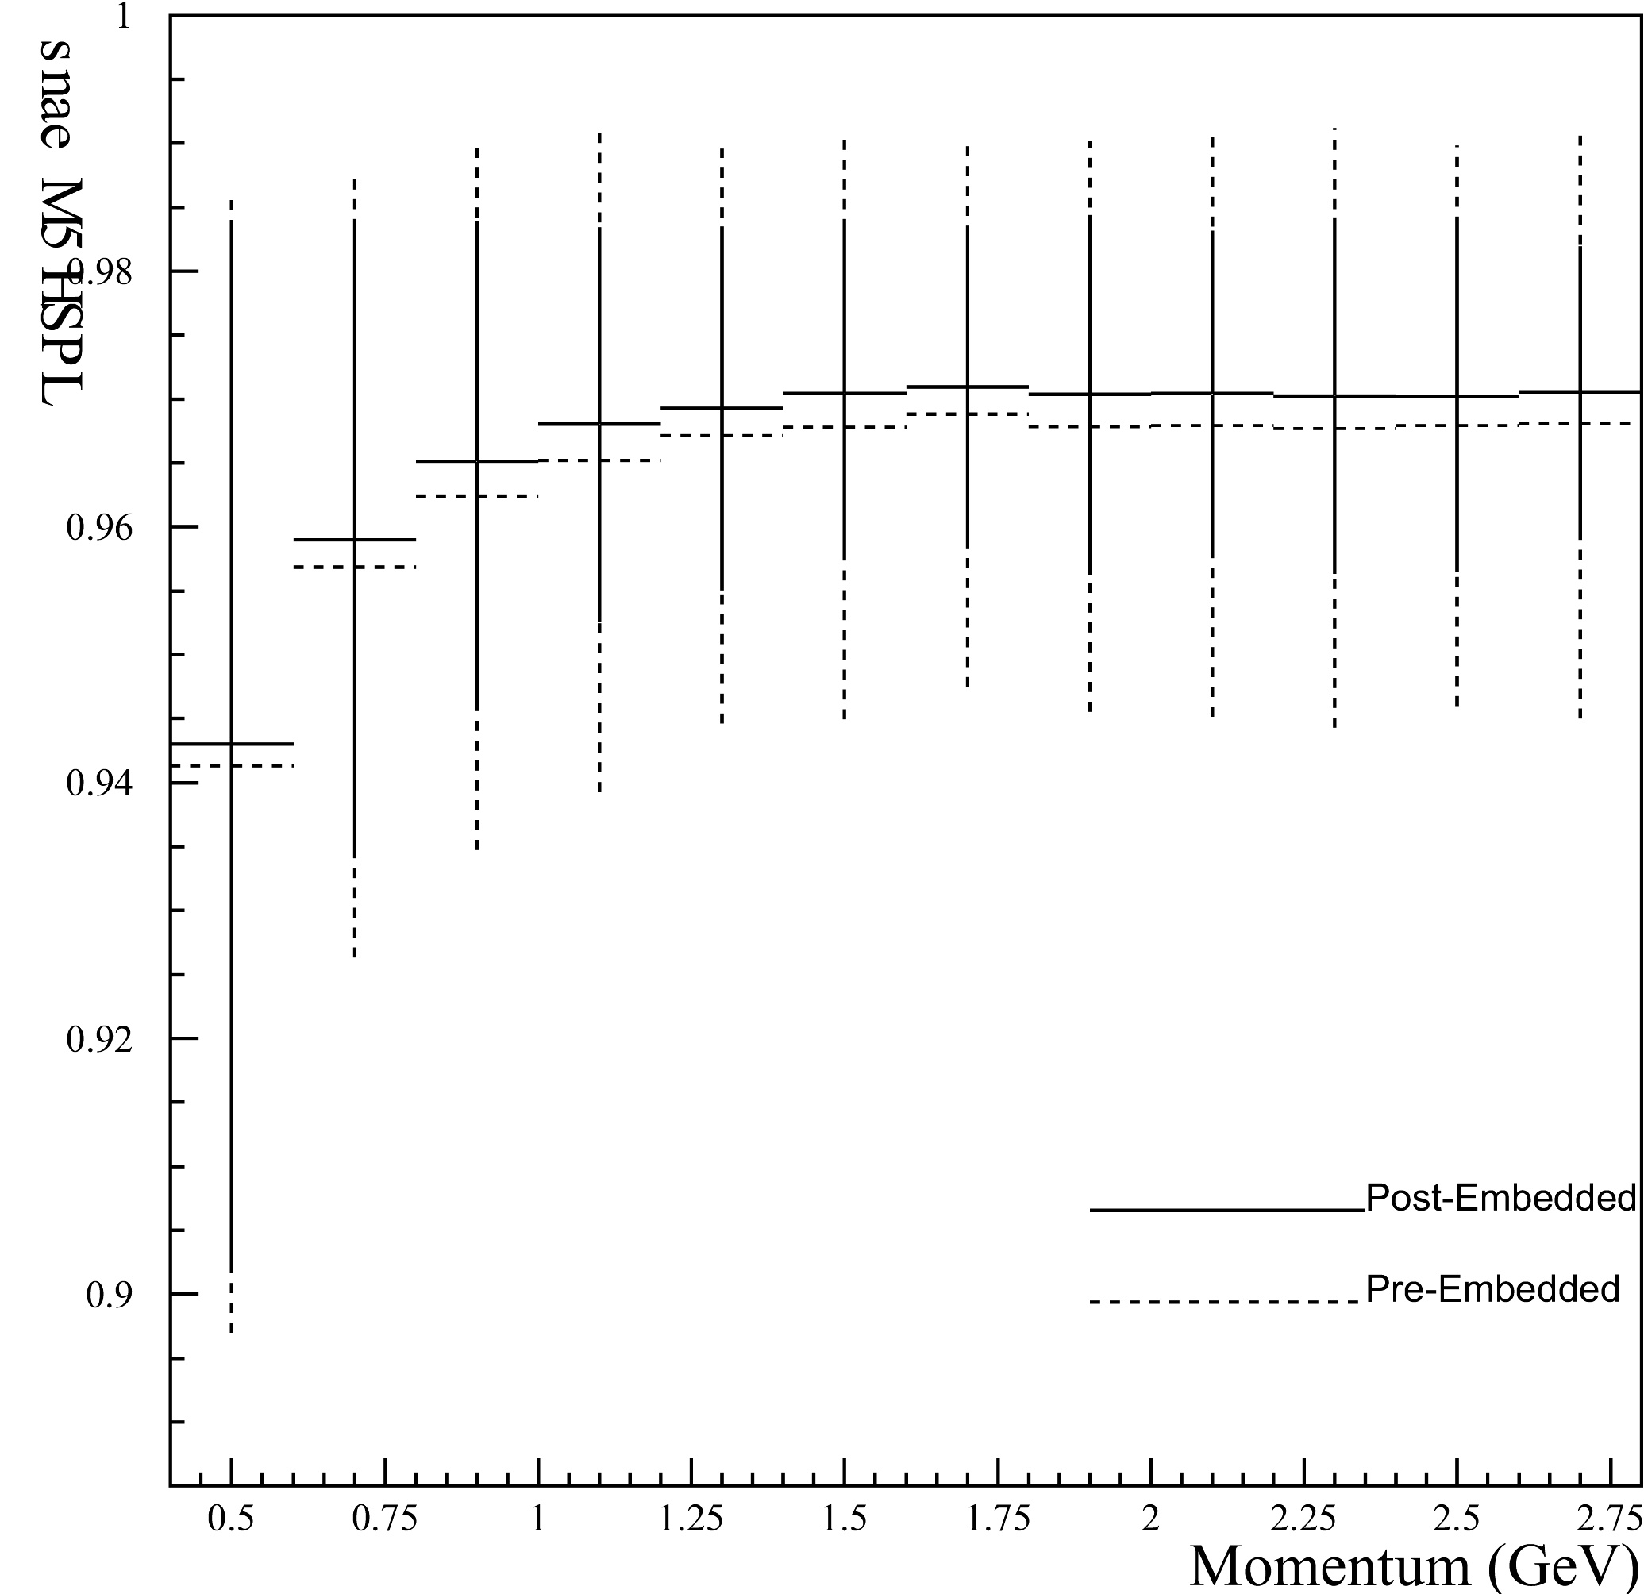

Figure 7 highlights the average value trends of LPSH4 and LPSH5 as function of momentum.

Conclusions

This Research Project should be able to help future researchers understand the properties of these variables. SGELDI, dE/dx have all been examined and behave the way we expected them to behave. We still need to examine the variables on the level they interact with each other. We need to know what percent of the time a biased θ-width/φ-width will in turn bias E9/E25, or will it bias the clean E9/E25 at all. When we are able to attain this information, then we will be ready to modify the existing electron identification code and increase our efficiency for finding electrons and positrons.

Acknowledgments

I am pleased to acknowledge Dr. Mark Palmer of the University of Illinois Urbana-Champaign, and Dr. Dan Cronin-Hennessy, of Rochester University, who proposed this Research Experience for Undergraduates project and guided my effort. This work was supported by the National Science Foundation REU grant PHY-9731882 and research grant PHY-9809799.

