**ACCELERATOR PHYSICS SEMINAR**

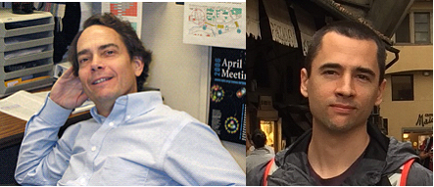

***Drs. Jim Crittenden & Stephen Poprocki***

Cornell University

**Recent Advances in Electron Cloud Buildup Measurements and Models at CESR**

*Tuesday, October 16, 2018*

*4:00 p.m. – 5:00 p.m.*

*Large Conference Room, Bldg. 911B*

*Abstract*

The Cornell Electron Storage Ring Test Accelerator program obtained from 2009 through 2017 ever-improving measurements of a variety of sources of emittance growth limiting the performance of CESR and future low-emittance rings such as the damping rings for linear colliders and high-brightness X-ray beam sources. The past year has witnessed

important advances in the mature analysis of the data sets, as well as major progress in the sophistication of our understanding of the underlying physics by means of numerical modeling of electron cloud buildup. The latter now includes the first detailed calculations of electron production mechanisms sourced by interactions of synchrotron-radiation photons in the CESR vacuum chamber walls. This work is attracting the attention of accelerator physicists at a number of facilities, particularly at CERN in Switzerland and KEK in Japan, where electron cloud effects are important contributors to performance limitations at the LHC and SuperKEKB storage rings. We describe this recent work and include quantitative assessments of potential consequences for the upgrade of the Cornell High Energy Synchrotron Source to be commissioned in November.

*Website for additional C-AD Seminar information:*

<http://www.c-ad.bnl.gov/AP/APseminar.html>