Demerger and Dump
The demerger serves for separating the high-energy and low-energy beams. It is located directly after Linac-B, the south string of SRF structures. The high-energy beam has an average energy of $\left\langle E\right\rangle ≃$5GeV and narrow rms energy spread, $σ_{δ}={δE}/E≃2⋅{\text{10}}^{−4}$. The low energy beam, which has already been used for x-ray production, has an average energy of $E>$15MeV, and an absolute energy spread of $ΔE≃±$5MeV. The line that transfers this beam to the dump therefore needs to have a very large energy acceptance and has to be able to accept significant beam loss.
One peculiarity of this system is associated with very low emittance of the beam, as low as $ε_{x}≃ε_{y}≃$8pm at 5 GeV (see section A.1). Down to 15 MeV this emittance comes to be 5000/15 times larger, $ε_{x}≃ε_{y}≃$2.7nm So even with envelop function $β_{x,y}$~20 meters, the beam size remains $σ_{x,y}≃\sqrt{2\text{.}7⋅{\text{10}}^{−9}⋅\text{20}}≃$ 232 $μm$. Meanwhile large beam size is a crucial parameter for lowering the power density in a beam dumping system. On the other hand, significant energy spread generates substantial beam size in the horizontal even with moderate dispersion function, but the vertical spot size has to be made large by optical elements.

Demerger Optics and Engineering
The two beams with two distinct energy spectra have to be separated by bending magnets and a complementary set of quadrupoles. This scheme represents an achromatic bend.
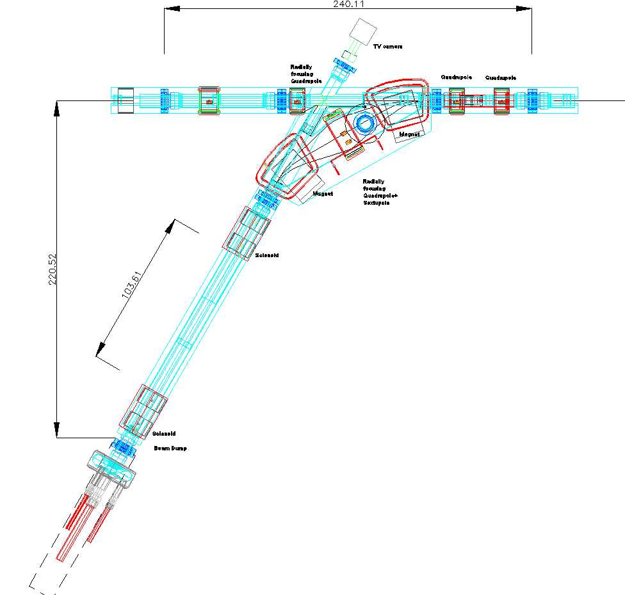
Figure C.1.10.1-1: The achromatic section of bends used to separate high and low energy beams. It uses two bending magnets and a quadrupole in between. This quadrupole is equipped with a sextupole corrector. Dimensions are given in cm.
Each magnet bends the low-energy beam by $ϕ=$30º degrees, with a bending radius of $R≈$0.5m. To compensate the dispersion generated after the separation magnet, each line is equipped with a radially focusing quadrupole and a complementary bending magnet, so the bend for each line becomes achromatic. The 5GeV beam line has additional quadrupoles for focusing in the vertical direction. It is bent by the first magnet by $Δϕ≃\text{30}{°×\text{15}}/{\text{5000}}≃0\text{.}\text{09}°$, i.e. ~1.6 mrad only.triplet of lenses is used to equalize the horizontal and vertical envelop. A solenoid installed in front of the beam-dump is used for control of the beam size on the dump unit. This solenoid produces a crossover closely behind its exit, allowing rapid expansion of beam dimensions as shown in Error: Reference source not found. The calculations were carried out with the code OPA and checked with the code WINAGILE. Beam emittances and beta functions were taken to be $ε_{x}≃ε_{y}≃$1nm and 15m, respectively.
A significant distance of about 3.5m is required after the solenoid, at which the beam will touch the walls of the full power beam dump. A TV camera equipped with a far-focusing optics looks inside the dump to detect sparking and hot spots. The chamber inside the solenoid has graphite cylinders protecting the walls against electron loss. The outside of the solenoid is cooled by water loops. At the entrance of this demerger, before the first bending magnet, a graphite collimator is installed inside the vacuum chamber between the first two quads as shown in Figure C.1.10.1-2 (right). The beam in between the two bends in Figure C.1.10.1-2 is approximately ±7cm wide, the vacuum chamber has to be adequately wide. It is made from aluminum for reduction of activation. The wide side walls of the chamber are covered by graphite absorbers to protect against beam loss by energy fluctuation.
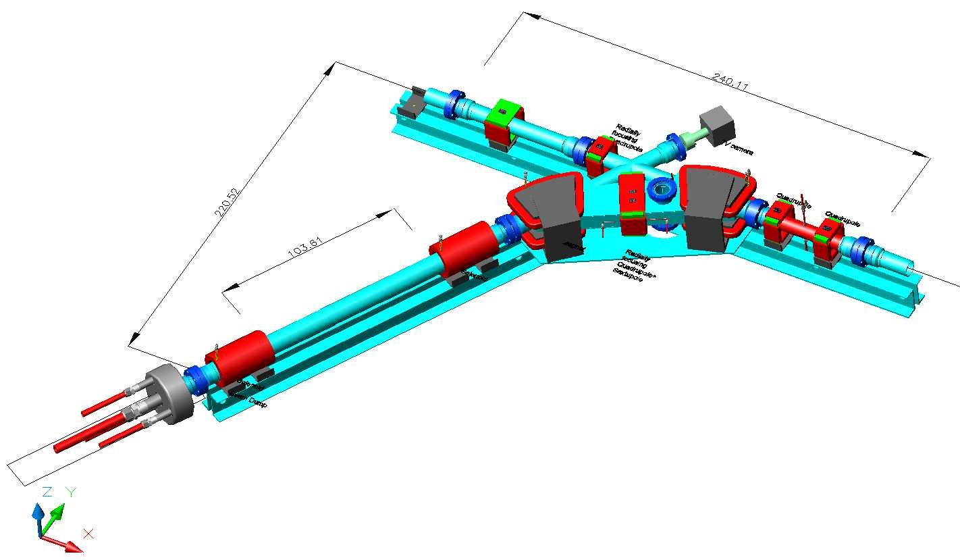
Figure C.1.10.1-2: The demerger unit is shown here with the small beam dump for commissioning. Solenoids serve for symmetric beam size control. The beam is coming from the right. Dimensions are given in cm.
First solenoid will be equipped with set of dipole coils for generation of orthogonal fields. These coils will sweep the electron beam in transverse direction with AC currents shifted in phase with 90º at 50 Hz, so the sweep will be a circular one.
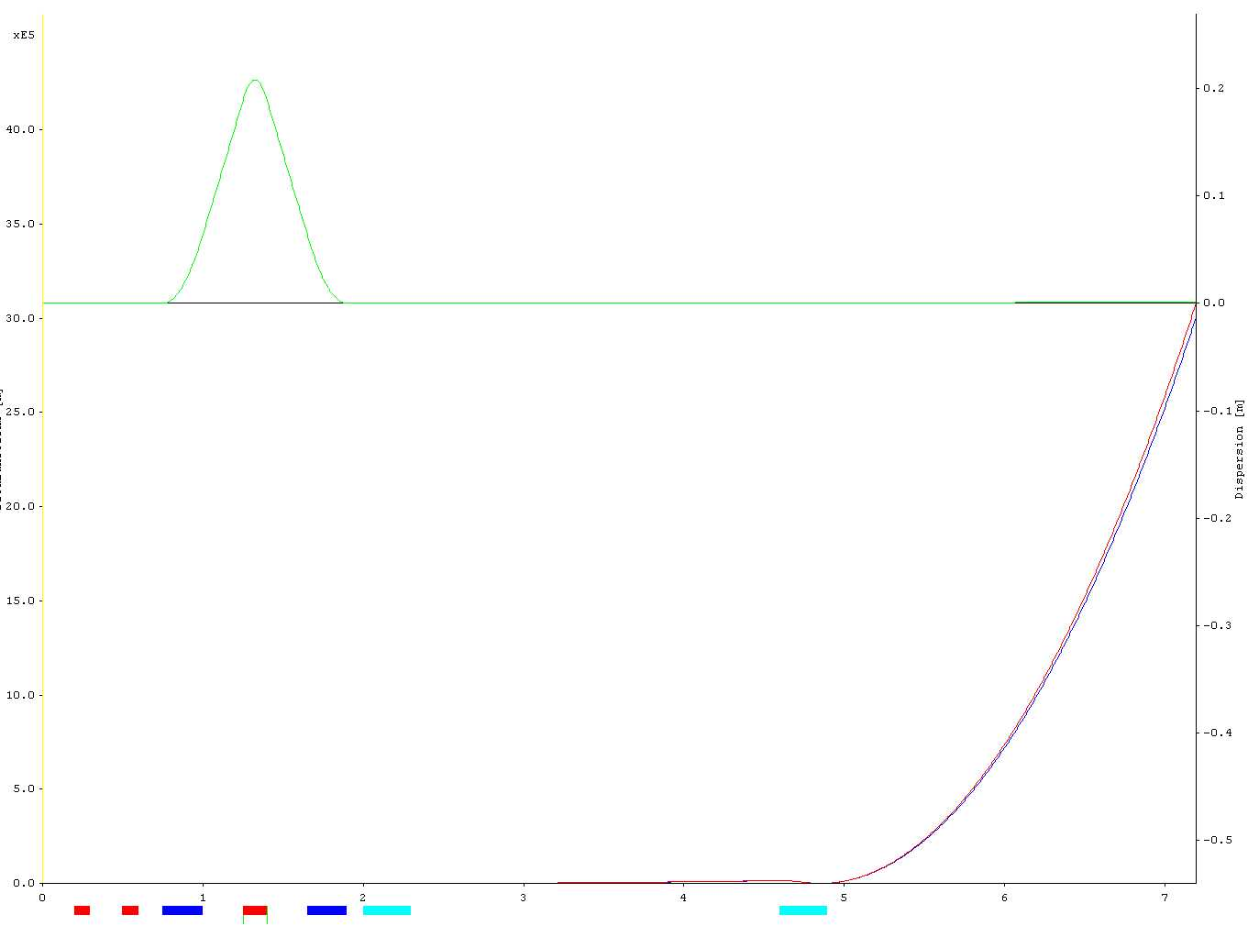

Figure C.1.10.1-3: Envelop functions and dispersion. Beam is coming from the left.
Figure C.1.10.1-4: Dispersion and envelopes(top two graphs). Beam envelops for ±20% energy spread in the vertical (third from top) and horizontal (bottom) planes. Beam is coming from the left. The dashed line shows the envelope for particles with the design energy of 15 MeV.
Because the energy of the beam is low, the focusing lens can be constructed as Panofsky-Hand quadrupoles. These lenses are equipped with sextupole correction windings to compensate the quadrupoles chromaticity contribution. The windings in the rectangular frame are generated by a linear current variation at the top and bottom poles and by a parabolic current distribution at the side walls of the quadrupole.
The septum is made as a copper rod wrapped by a pyrolithic graphite cylinder having tight a thermal contact with the copper road. The rod is cooled from the outside to protect the vacuum chamber from water vapor.
Another possible solution for the magnets might be a permanent magnet with a coil for field control. This would add protection of the dump area in case of failing power supplies, a practice that is typical for high power systems.
Graphite absorbers.
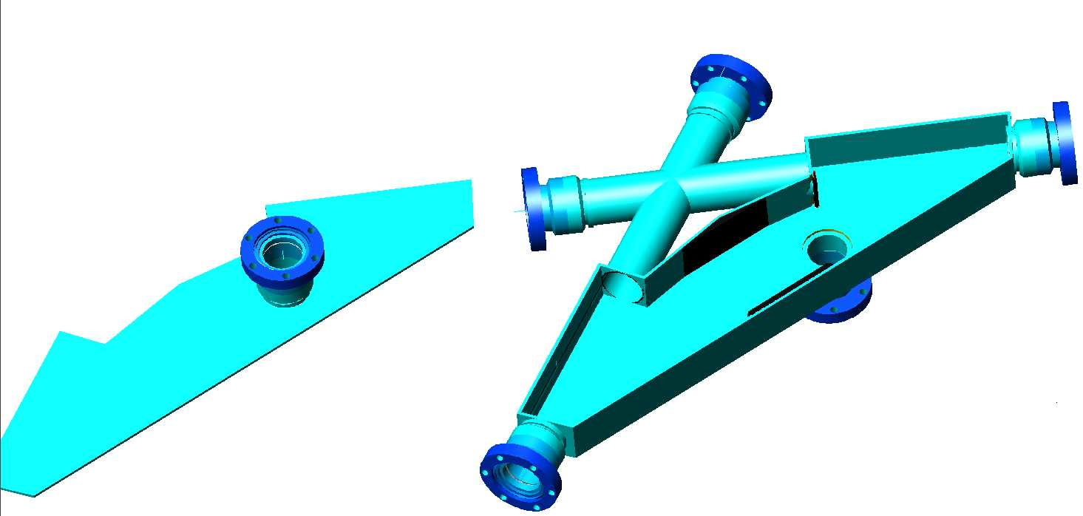
Figure C.1.10.1-5: Graphite absorbers are shown in the central, wide part of the aluminum vacuum chamber.

