GENEVE, SUISSE
GENEVA, SWITZERLAND

Mail address: CERN
CH-1211 GENEVE 23
Switzerland Prof. David Rubin
Chair of the 2005 APS Outstanding
Telex / Telex : 419000 CER CH Doctoral Thesis Research in Beam Physics
Télégramme/Telegram : CERNLAB-GENEVE Award Selection Committee
Téléfax/fax : +41 (22) 783 0552
Téléphone/Telephone :
Direct : +41 (22) 767 9054
Central/Exchange : +41 (22) 767 6111
E-mail : frank.zimmermann@cern.ch

Votre référence/Your reference:
Notre référence/Our reference:

Geneva, 30 October, 2005

Dear Prof. David Rubin (dear Dave),

It is a great pleasure for me to write this letter in support of the nomination of Kip Bishofberger for the APS Outstanding Doctoral Research in Beam Physics Award. In my opinion, Kip deserves this prize for his substantial contributions to beam-beam compensation with an electron lens at the Tevatron. He has been a driving force in every aspect of the Tevatron electron lens project, e.g., design, fabrication, testing, machine studies, repairs and upgrades. The results of his work have important implications for any future collider.
During two extended stays at Fermilab in 2002 and 2004, I participated in several Tevatron experimental studies making use of the electron lens. I was deeply impressed by the scope of Kip’s involvement, unusual for a student, by his technical knowledge, as well as by his communication skills. I have also had the privilege of attending an FNAL “Budker seminar” for doctoral students, in which Kip presented his thesis work and diligently answered a multitude of challenging questions.
I have no doubt that Kip would be a worthy recipient of the APS Outstanding Doctoral Research award and herewith I strongly recommend him for your consideration.
Please do not hesitate to contact me if you have any questions.

Sincerely yours,
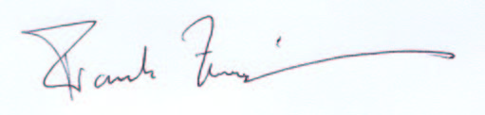
Dr. Frank Zimmermann
CERN, Accelerators & Beams Department / Accelerators & Beam Physics Group

