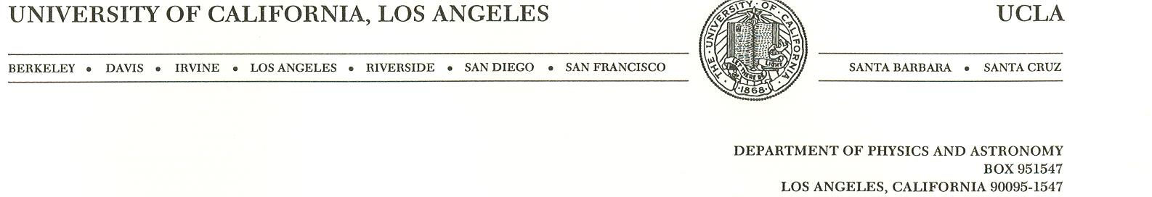

Professor Claudio Pellegrini

October 20, 2005

Professor David L. Rubin
Chair, Outstanding Doctoral Thesis Research in Beam Physics Award
Cornell University
Newman Laboratory
Ithaca, NY 14853

Dear Professor Rubin:

I am writing this letter to submit the nomination of Dr. Pietro Musumeci for the Outstanding Doctoral Thesis Research in Beam Physics Award.
Pietro obtained his PhD at UCLA in the Fall of 2004, with an experimental thesis on laser acceleration of electron beams, using an Inverse Free-electron Laser (IFEL). Successful proof-of-principle IFEL experiments were done before this thesis, showing that along with acceleration, this scheme offers the possibility of manipulating and controlling the longitudinal phase space of the electron beam on the laser wavelength scale. First among other laser accelerator schemes, the IFEL has experimentally demonstrated beam micro-bunching at the laser wavelength, phase-dependent acceleration, phase-locked external injection using a buncher-accelerator scheme and high trapping efficiency and control of the final energy spread. Despite this significant progress, in all these experiments the energy gain was modest and the measured acceleration gradient was below that achieved in conventional rf accelerators.
Pietro was given the task of designing and performing an experiment that would give a significant energy increase and a large acceleration gradient, using the 14.5 MeV electron linac and the high power, about 500MW peak, CO₂ laser of the Neptune laboratory at UCLA. Thus the goal of his thesis was to use the IFEL to produce significant energy gain and gradient, while preserving the longitudinal characteristic of the electron bunch.
A critical issue was to try to understand how to use in the most efficient way the laser power available, given the low energy of the input electron beam. Pietro expanded for the first time the IFEL theory to incorporate the diffraction effects that become important when a laser beam is strongly focused to increase the acceleration rate. The undulator design was also modified to take into account these effects. Pietro developed the simulation tools needed to study and design the IFEL. The simulations were very important for the undulator design, and to estimate the tolerances of the undulator field and of the electron beam-laser beam alignment. Using these tools he designed a strongly tapered undulator with many features at the cutting-edge of magnet technology. The undulator was built in Moscow, at the Kurchatov Institute, and brought to UCLA, were it was measured again by Pietro and the Kurchatov group. In fact, the change of the period wavelength and field amplitude inside the undulator is very significant and makes the engineering, construction and the tuning of such unique structure a very challenging task.
The various aspects of the experimental setup were analyzed and studied in detail by Pietro, including the optics to focus the laser beam to the desired spot size inside the undulator, corresponding to a Rayleigh range of 1.8 cm, the damage to the optical elements, the input electron beam delivery, the synchronization between electron and laser pulses -critical for every laser accelerator -, the undulator alignment tolerances, the IFEL output diagnostics [].
Electrons with energies up to 35 MeV were observed in the experiment []. A few per cent of the injected particles are trapped in a stable accelerating bucket. Experimental data on the dependence of the acceleration on injection energy, laser focus position, and laser power were obtained and discussed. Three-dimensional simulations, in good agreement with the measured electron energy spectrum, indicate that most of the acceleration occurs in the first 25 cm of the undulator, corresponding to an energy gradient larger than 70 MeV/m. The energy gain is the highest obtained to date with an IFEL accelerator. Self-trapping of particles in a stable accelerating bucket from an initial not micro-bunched distribution was also demonstrated in this experiment for the first time.
Finally, the structure of the measured energy spectrum shows a novel effect, the higher harmonics interaction, that was observed and explained for the first time in this experiment by Pietro and could lead to important innovations in future IFELs []. The possibility of coupling the laser wave and the electron beam on a different spectral line of the undulator radiation was studied in detail theoretically and with the help of the simulations. In some cases, the strength of the higher harmonic IFEL coupling is seen to be comparable to the fundamental coupling and efficient energy exchange can take place in higher harmonically tuned undulators. In general, this offers a new degree of freedom when designing systems coupling high power laser beams and relativistic electron beams. Pietro was the author of the observation and theoretical explanation of this new effect.
In summary, Pietro’s IFEL experiment obtained the largest energy increase in a laser accelerator. He measured the effect of harmonics and understood the important role that they can play in IFELs. To perform the experiment he also had to overcome the technical challenges of synchronizing and aligning to tight tolerances the laser and electron beams. To do this he developed new diagnostics, including Cherenkov detectors and other tools. In his work he has shown an outstanding capability to design and successfully perform a difficult experiment, taking and analyzing data and discovering new effects. He has shown to be a very, very good experimental physicist, also capable of deep theoretical understanding and the development of simulation tools.
As one can see from the enclosed publication list, Pietro has also published a large number of papers on other subjects, demonstrating outstanding creativity and originality. His work has been recognized by two invited talks at the Advanced Accelerator Concepts in Stonybrook, NY, 2004, and the Particle Accelerator Conference at Knoxville, TN, 2005
I am very pleased to strongly and enthusiastically nominate him for the Outstanding Doctoral Thesis Research in Beam Physics Award.

Sincerely
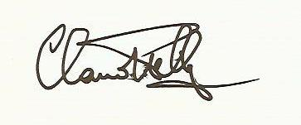
Claudio Pellegrini
Distinguished Professor of Physics

P. Musumeci, C. Pellegrini, J. B. Rosenzweig, S. Ya. Tochitsky, G. Travish, R. B. Yoder, A. A. Varfolomeev, S. Tolmachev, A. A. Jr. Varfolomeev, T. Yarovoi. Status of the Inverse Free Electron Laser Experiment at the Neptune Laboratory Proceedings of 2003 Particle Accelerator Conference. IEEE, 2003, pp.1867-9, Piscataway, NJ, USA.
P. Musumeci, S. Ya. Tochitsky, S. Boucher, A. Doyuran, R. J. England, C. Joshi, C. Pellegrini, J. Ralph, J. B. Rosenzweig, C. Sung, S. Tolmachev, G. Travish, A. Varfolomeev, A. Varfolomeev, Jr., T. Yarovoi, and R. Yoder, Very High Energy Gain at the Neptune Inverse Free Electron Laser Experiment, Advanced Accelerator Concepts. Eleventh Workshop, Stony Brook, NY, USA, AIP. Conf. Proc., 737, 160, (2004) P. Musumeci, S. Ya. Tochitsky, S. Boucher, C. E. Clayton, A. Doyuran, R. J. England, C. Joshi, C. Pellegrini, J. E. Ralph, J. B. Rosenzweig, C. Sung, S. Tolmachev, G. Travish, A. A. Varfolomeev, A. A. Varfolomeev, Jr., T. Yarovoi, and R. B. Yoder. High Energy Gain of Trapped Electrons in a Tapered, Diffraction-Dominated Inverse-Free-Electron Laser Physics Review Letters 94, 154801 (2005) P. Musumeci, S. Ya. Tochitsky, S. Boucher, C. E. Clayton, A. Doyuran, R. J. England, C. Joshi, C. Pellegrini, J. E. Ralph, J. B. Rosenzweig, C. Sung, S. Tolmachev, G. Travish, A. A. Varfolomeev, A. A. Varfolomeev, Jr., T. Yarovoi, and R. B. Yoder High Energy Gain of Trapped Electrons in a Tapered, Diffraction-Dominated Inverse-Free-Electron Laser Virtual Journal of Ultrafast Science (2005)
P. Musumeci, C. Pellegrini, and J. B. Rosenzweig. Higher harmonic inverse free-electron laser interaction Physics Review E 72, 016501 (2005)

