STATUS REPORT

Development of a Micro Pattern Gas Detector Readout for a TPC

Personnel and Institution(s) requesting funding

D. P. Peterson, R. S. Galik, Laboratory for Elementary-Particle Physics,
Cornell University
G. Bolla, I. P. J. Shipsey, Physics Department, Purdue University

Collaborators

none

Contact Person

Dan Peterson
dpp@lns.cornell.edu
(607)-255-8784

Project Overview

Motivation

Unprecedented tracking performance, in both multi-track separation and momentum resolution, is required to meet the experimental physics goals of the International Linear Collider (ILC). A time projection chamber (TPC) may provide the best combination of detector segmentation and continuous track measurements, leading to optimal multi-track separation and noise immunity. However, as described below, the segmentation of current technology TPCs is insufficient for precision reconstruction of ILC events. In addition, obtaining spatial resolution that is required to meet the momentum resolution goal is challenging with the current technology. This prototyping project is part of a world-wide coordinated study to develop a TPC readout with the segmentation and resolution required for the ILC program.

Multi-track separation, which leads to efficient track reconstruction, is required for an “energy flow analysis”, the precision measurement of jet energies using tracking information to determine the charged energy component [1]. Energy flow analysis will require efficient track reconstruction within jets where the track density is of order 100 tracks/steradian. TPCs using multi-proportional-wire-chamber (MWPC) gas-amplification, of which the STAR and ALEPH chambers are typical examples, have pad readouts with segmentation of order 1 cm in the azimuthal direction. This segmentation is insufficient for reconstructing tracks in dense jets. For example, consider a TPC with 1 cm pads, effective 4 cm longitudinal separation, and a two-pad FWHM pad response function. The solid angle segmentation would be about 10⁻³ steradian at a detector radius of 1 meter. Thus, the pad occupancy within a jet would be 10% - a challenging environment for track reconstruction. In a simulation of digitized detector response [2], a 1 cm pad width was shown to provide only 94% reconstruction efficiency while a pad width of 2 to 3mm is required for the ultimate resolution. Simply increasing the detector segmentation in a wire anode TPC will not result in increased reconstruction efficiency because the signal width is determined by the inductive readout. A gas-amplification technology with pad response function width less than 2mm is required to take advantage of increased readout segmentation.

Spatial resolution, which determines charged particle momentum resolution, is also limited in MWPC TPCs. Charged particle momentum resolution, σ(1/p), of order 10⁻⁵/GeV is required to determine the Higgs mass through the precision measurement of the recoil mass of di-leptons in Higgsstrahlung events [3,4]. Similar momentum resolution is required to measure the end-point momentum in leptonic supersymmetric decays. This momentum resolution can be achieved only if the TPC spatial resolution is of order 100μm. This spatial resolution is very challenging in a MWPC TPC not only because it represents 1% of the pad size but also because the radial electric field in the vicinity of the wires leads to a significant spatial distortion.

A TPC readout based on a micro-pattern-gas-detector (MPGD) gas-amplification device such as a GEM [5] or Micromegas [6] promises to provide both improved segmentation and resolution. Segmentation is improved due to a fundamentally reduced transverse signal size; the signal is created on pick-up pads by electron transport rather than induction. The pad size can then be significantly reduced. Spatial resolution is improved due to the reduced signal size and reduced ExB distortion of the drift path in the vicinity of the amplification device. Operation in a high rate environment may be simplified because these readout systems are expected to naturally suppress ion feedback into the drift volume.

The world-wide study TPC study

Research groups in Europe, Canada, and Asia, as well as the Cornell/Purdue group in the United States, have joined to form the LC-TPC group [7] and are currently studying gas-amplification devices in prototype TPCs. The LC-TPC group meets regularly at the international and regional workshops. Groups from Victoria [8], DESY [9], Karlsruhe [10], and Aachen [11] have been studying GEM gas-amplification. The Berkeley/Orsay/Saclay [12] group has been studying Micromegas gas-amplification. The Carleton [13] group has been studying Micromegas gas-amplification with an additional resistive foil over the pad plane to control the pad response function. The Asia/MPI/DESY group, joined by Carleton and Berkeley/Orsay/Saclay has made comparative measurements [14] with wire, GEM and Micromegas gas-amplification devices operated in a common TPC. As described later, the Cornell/Purdue group is also making comparative measurements.

Results from the individual groups and recent reviews [15] of this work have been presented at the linear collider workshops. Results from these groups are encouraging; several groups report spatial resolutions of less that 100 μm with MPGD devices. However, the results are preliminary. Measurements of different gas-amplification devices are difficult to compare because they are taken by different groups under various conditions. In addition, there are sometimes discharge problems in the gas-amplification devices that must be understood. Significant development and operating experience, involving many groups, are required before a full-size design for a detector incorporating a GEM or Micromegas can be finalized.

Groups within LC-TPC will continue to study the MPGD devices in small TPCs for the next one or two years. At the same time, LC-TPC is beginning the design stage of a large collaborative prototype [16], with radius about 80 cm to study issues associated with operating a TPC employing a system of the MPGD devices. A magnet with 85 cm bore and 1.5T field is being assembled with EUDET funds at DESY to provide a facility for this next phase in ILC TPC development [17]. EUDET will provide the TPC field cage and other infrastructure. LC-TPC participants will provide the endplates, readout devices and the electronics. To stay on schedule for the construction of the final TPC for an ILC detector, the design must be completed in 2006, the construction in 2007, and commissioning in 2008. Thus, the design and construction are concurrent with this proposal.

The Cornell/Purdue program

Current efforts at Cornell and Purdue utilize a prototype at Cornell (see "Status") with a goal of directly comparing the response and reliability of different gas-amplification devices while minimizing the systematic differences of readout electronics and other experimental conditions. These measurements address critical design choices for the TPC in both the LDC and GLD concepts. These measurements will compliment similar measurements being made with the MPI prototype TPC at KEK.

An important distinction of the Cornell/Purdue prototype, when compared to the other small prototypes, is the readout electronics. Other groups are using prototype or decommissioned electronics from the STAR and Aleph TPCs. These electronics typically have lower dynamic range. The Cornell/Purdue group has a background in small-cell drift chambers and did not have access to electronics suitable for reading out a TPC. The necessary purchase of commercial electronics has provided a readout system that, although limited to fewer channels, has higher dynamic range and improved noise suppression. Using these electronics, we are capable of making measurements that may not be possible with other electronics.

The readout system described above allows the Cornell/Purdue group to perform comparative measurements of ion feedback. Ion feedback presents a serious limitation to operating a TPC. Positive ions drifting back into the drift volume cause time-dependent distortions to the electron drift path. In MWPC gas-amplification TPCs, the ion-feedback is controlled by a gating grid. The gating grid adds complexity, internal stresses and material to the TPC endplate that we seek to avoid at the ILC. Although the GEM and Micromegas devices have reduced ion-feedback, it must be demonstrated that the natural suppression is sufficient to eliminate the need for a gating grid. The Berkeley/Orsay/Saclay group has made measurements of ion feedback [18] with Micromegas gas-amplification. Aachen has made similar measurements with triple-GEM gas-amplification [19]. In both cases, measurements were made with a small drift length and with the primary ionization created by an intense source. Feedback was measured via the current through the drift volume cathode. In contrast, Cornell/Purdue plans to measure ion-feedback on individual tracks by measuring individual ion signals on the drift field termination grid (shown below in figure 4). These measurements will directly compare MWPC, GEM and Micromegas gas-amplification devices and provide input to the critical design choice of whether it necessary to implement a gating grid in the TPC for both the GLD and LDC concepts.

Longer range studies will involve the large prototype being planned by the LC-TPC group. Plans of the Cornell/Purdue group to build at least one endplate have been encouraged by LC-TPC. This effort would draw on the Cornell group's experience in building large drift chambers (see "Experience"). There are important issues regarding the tiling of the TPC endplate with MPGD devices that must be studied with the large prototype. The tiling of GEM modules may follow a different design than the tiling of Micromegas modules because, in the case of the GEM, the gas-amplification devices can be separated from the pad board. This allows a rather large pad board to be associated with several GEM tiles. This is not the case for the Micromegas where the gas-amplification device must be inherently bonded to the pad board. In both cases, we must devolope a procedure for locating the modules with a precision of 50μm because track-based alignment will be affected by magnetic field distortion uncertainties [20]. At the same time, the endplate structure must be low mass to reduce the interactions of electrons and photons before entering the forward calorimeters. Finally, inactive areas between modules must be minimized. Cornell/Purdue will work with other LC-TPC groups to design the endplate and industrialize the manufacture of the readout modules.

We anticipate that the development of a large prototype endplate will require a two-step process. A preliminary design will be machined at Cornell. After evaluation of the preliminary design and design revisions, a final endplate will be fabricated at a commercial machining facility. Experience in building the CLEO III endplates and the CLEOc inner drift chamber lead to cost estimates for the commercial machining and certification of an endplate of this size of about $80K.

Purdue will be involved in the design and prototyping of readout modules used for populating the endplate. Development will be done in cooperation with other interested LC-TPC groups and will lead to a design that can be transported to other institutions.

As described below (see "Expertise"), Purdue is involved in several studies of manufacturing techniques for the purpose of providing large scale production of reliable GEMs. and Micromegas. It is expected that the MPGD manufacturing will require 3 to 4 years of development. The development of new manufacturing techniques for GEMs and Micromegas is important because it may provide reduced cost and procurement time for large scale implementations such as a TPC or a hadron calorimeter in a linear collider. Much of this work is at an early stage; extensive R&D and testing, including radiation hardness studies, will be required. Funding exists for this work and we are not seeking additional funding for it at this time. These studies will be performed by many groups, including Purdue, over the next few years. We expect to incorporate each of the successful alternative manufacturing technologies into TPC readouts. The Cornell TPC will be used to test and compare MPGDs that are manufactured with new techniques as well as devices produced at CERN.

Our coordination with the world TPC study will be strengthened by cooperating on projects of mutual interest with the Carleton group consisting of Prof. Alain Bellerive and Dr. Madhu Dixit. The infrastructure at Cornell will enable us to make a direct comparison of Carleton MPGD readout devices with those prepared at Purdue. This will help in reducing systematic uncertainties and in optimizing the readout design for the MPGD TPC. The partnership between Carleton and Cornell/Purdue will benefit from the geographic proximity of Ottawa and Ithaca.

Expertise

The Cornell experimental group has extensive experience building and commissioning drift chambers for the CLEO experiment [21]. For the CLEO II drift chamber [22], the Cornell group developed thin structures for inner and outer segmented cathode readouts. In the design stage of the CLEO III drift chamber [23], the Cornell group developed specialty parts and machining practices with commercial vendors. Prototype chambers were used to study questions of gas properties, insulating feed-through breakdown, electronics characteristics and mechanical issues for the endplate. The CLEO III drift chamber [24], installed in 1999, has been extremely reliable with superior spatial resolution and low mass. Most recently, the Cornell group constructed and commissioned a 6-layer inner drift chamber for the CLEOc program [25]. Two significant issues were resolved in this project: integrating the chamber design with the existing interaction vacuum chamber and focusing elements, and reducing the sensitivity to electronic noise transmitted by the beam pipe.

The Purdue group has many years of experience developing MPGDs [26-40]. In collaboration with the CERN and Saclay groups, radiation hardness of GEM and Micromegas foils manufactured at CERN have been studied and excellent radiation hardness has been demonstrated. The first triple-GEM [37] and GEM+Micromegas detector have been built. The latter has achieved the best signal-to-noise performance in a beam line of any MPGD to date [38] making it very attractive for TPC readout. In addition a new readout mode of a Micromegas has been developed that promises greater electrical robustness.

GEM manufacturing technology, for readily available samples, has been limited to Kapton lithography. Purdue is involved in several studies of alternative manufacturing techniques. In collaboration with the University of Chicago, a micro-machined large area LEM (large scale GEM) was built and successfully tested at Purdue [41]. Electrode-less GEMs and Micromegas, which have greatly reduced the amounts of material, are also under development. The Purdue/Chicago collaboration has worked with the 3M Corporation to develop a less expensive, large quantity, manufacturing process for standard GEMs.

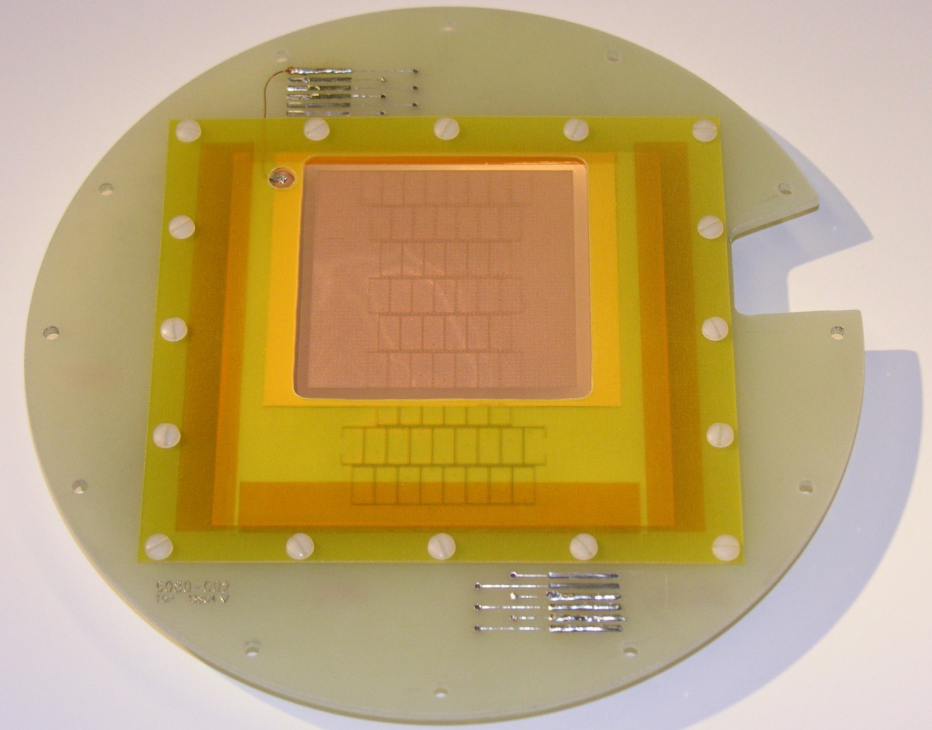

Figure 1: A Micromegas produced by the 3M Corporation in collaboration with Purdue University mounted on readout pad board in preparation for installing in the TPC..

These have been delivered and tested at Purdue and CERN. Preliminary results indicate that the performance of GEMs manufactured by 3M, when appropriate materials are used and the process is carefully controlled, is indistinguishable from the performance of those manufactured at CERN [42,43,44]. More recently, Purdue has collaborated with 3M to develop the first mass-produced Micromegas. These have been delivered [45] and are being prepared for testing in the Cornell/Purdue TPC (see "Status Report") as shown in Figure 1.

Work described in this section and in “Status Report” has been supported at Cornell by NSF cooperative agreement PHY-0202078, 4/1/2003 – 3/31/2008, entitled "Support of the Cornell Electron Storage Ring (CESR) Facility". Work at Purdue has been supported by DoE grant DE-FG02-91ER40681, 1991-present, entitled "An Experimental High Energy Physics Program at Purdue University".

Status Report

In December 2004, the Cornellgroup commissioned a TPC, shown in Figure 2, with a 64 cm drift field and 10 cm square readout aperture. Cornell purchased a low-noise high voltage system that provides 20kV for the drift potential as well as biasing voltages for the gas-amplification devices. Cornell also purchased a VME based DAQ system with low-noise power supplies to improve the signal sensitivity for prototype detectors. TPC signals are digitized with commercial flash-ADCs with 8 channels/unit, 105 MHz sampling rate, +/- 200mV input range, and 14 bit resolution. Cornell initially purchased a total of 32 channels.

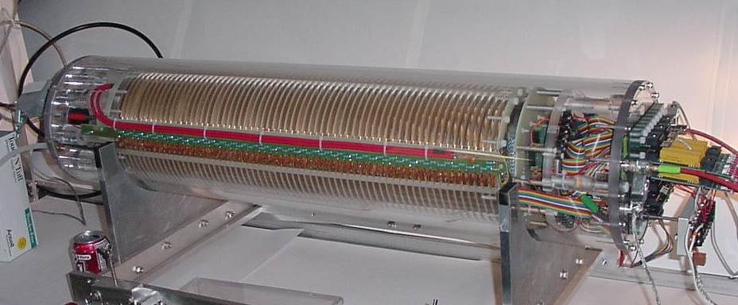

Figure 2: Time Projection Chamber at Cornell University. The drift cage has an inner diameter of 14.6 cm and length of 64 cm.

The TPC accepts interchangeable readout sections. A MWPC gas-amplification readout, shown in Figure 3 was used for initial tests in January 2005, with demonstration results shown at LCWS05 [46]. A single-GEM, operated with a gas gain of 100, was tested in April 2005, with results shown at Snowmass [47]. The single-GEM demonstrated the low-signal sensitivity that will be necessary to complete the ion-feedback measurements. A double-GEM was tested in October 2005, with results shown at Vienna [48]. For the initial tests, a coarse pad pitch, 5mm by 10mm, was chosen because it allowed us to demonstrate the
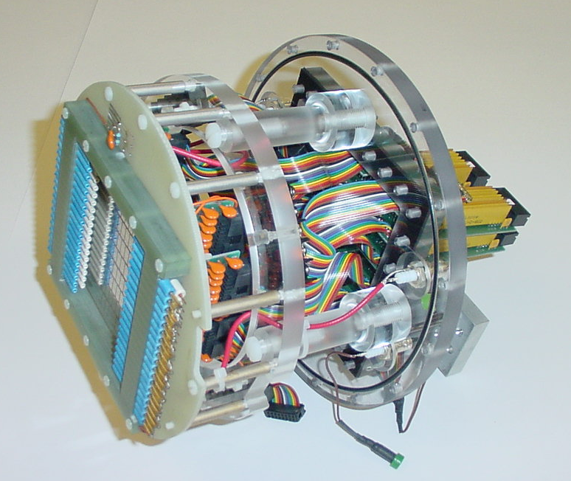

Figure 3: TPC Readout Module. A MWPC gas-amplification section is mounted in front of the pad board on the left. Pad biasing voltage distribution cards are mounted behind the pad board.

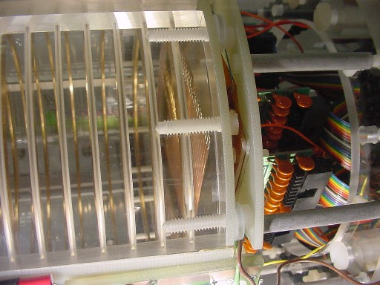

Figure 4: TPC field cage termination. The instrumented field cage termination plane is visible in front of the double-GEM gas-amplification readout module.
TPC operation with the minimum number of channels. Measurements are made with zero magnetic field using cosmic rays.

Resolution measurements are limited by the 5mm pad pitch of our present readout. While the width of the pad response function provided by MPGD gas-amplification
is a fraction of the pad width, measurements of the intrinsic resolution can be made only with tracks near the boundaries between pads. Using the double-GEM, shown in figure 4, measured signal widths are fully contained in 2.5mm for small drift distance and increase to 4mm with larger drift distance. We measure the point resolution, for signals with widths smaller that the pad width, by selects tracks with at least 4 layers having significant sharing of charge between 2 pads. The resolution,

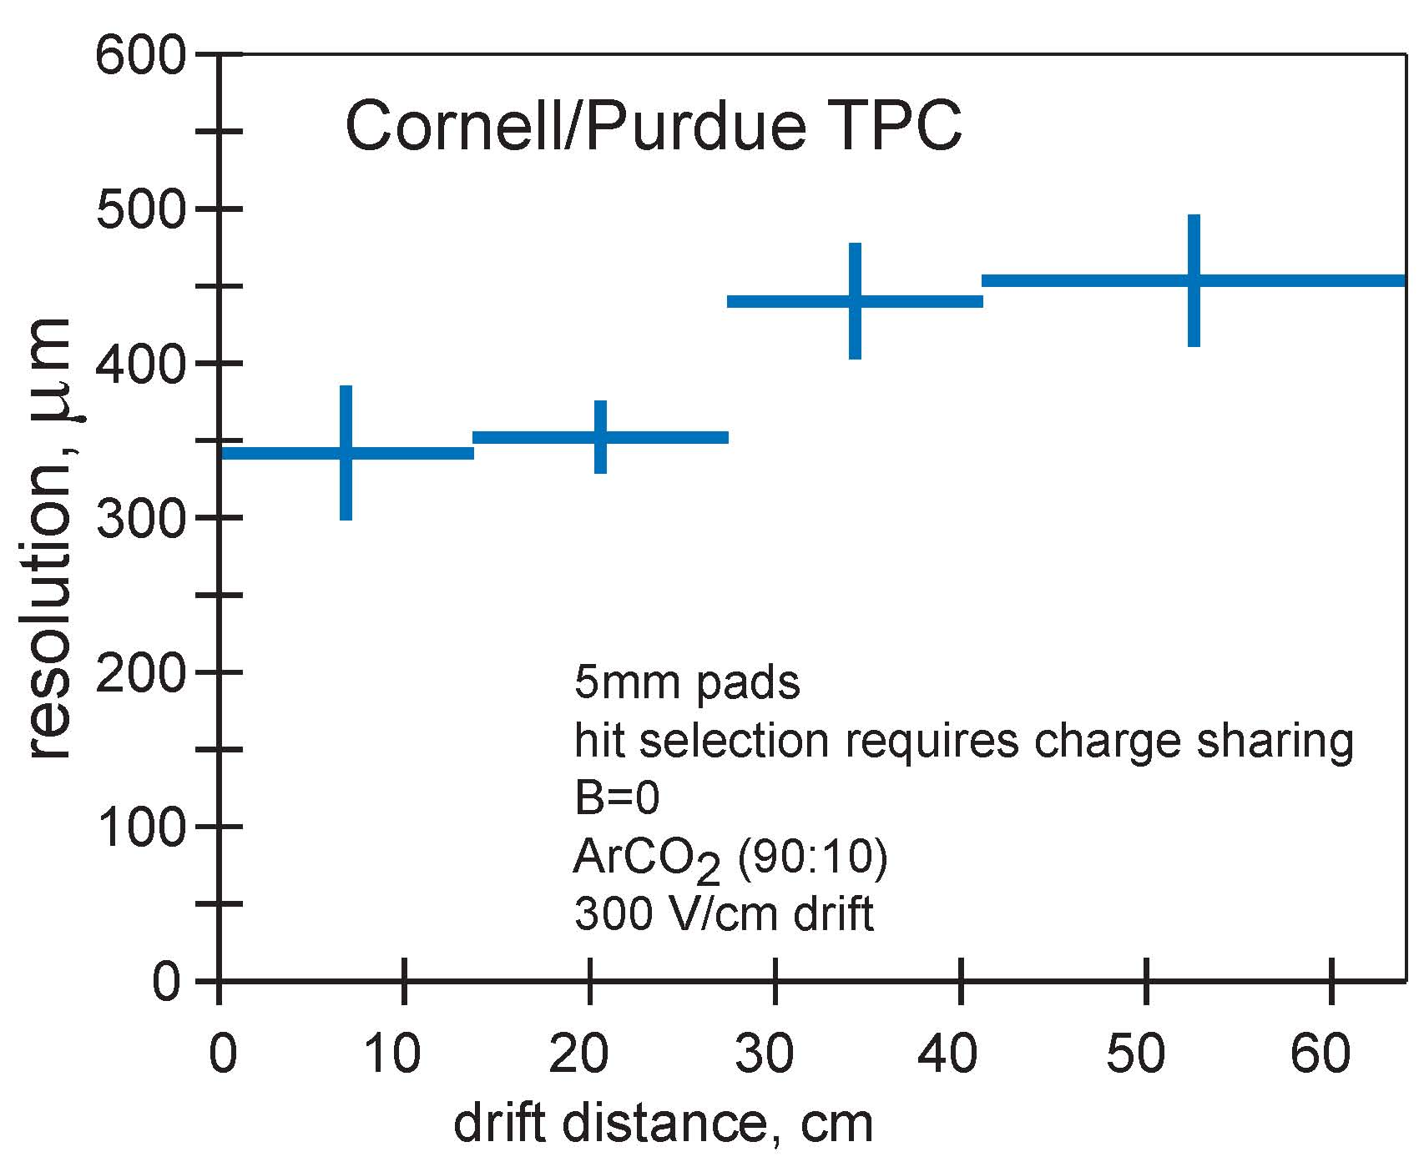

Figure 5: Point resolution as a function of drift distance. Tracks were selected with charge sharing hits in at least 4 rows. The resolution is derived from the RMS by correcting for (number of hits/dof)^{1/2} .

shown in figure 5, is expected to increase with drift distance due to diffusion. Measurements indicate that the readout modules and readout electronics perform as expected. However, more detailed comparisons of gas-amplification devices are limited with the 5mm pad width. Charge sharing is limited to two pads and the track selection severely limits the efficient.

The TPC and initial readout and HV electronics described above were procured and assembled using Cornell funds not derived from this grant. GEMs were purchased and tested using Purdue funds not derived from this grant

We are currently preparing for more sensitive resolution measurements and the ion-feedback measurements. Acquisitions include additional FADC channels and the additional of a positive HV supply that is part of the of the integrated HV system. The latter will provide more flexibility in biasing the gas-amplification devices and further noise reduction. Recently released first year funding from this grant will be used for other upgrades to this project. New readout boards with a sufficient number of 2mm pad rows will allow precision resolution measurements. The ion-feedback measurements require a pulsing bias control and fast-recovery preamplifiers for the instrumented field cage termination plane. These are being designed and built at Cornell.

Completion of the 1st year deliverables: comparative measurements including signal width and operational stability of MWPC, double-GEM and Micromegas gas-amplification devices, using the 5mm pad readout, is ongoing.

FY2006 Year Project Activities and Deliverables

Activities funded under the second project year will include the continuation of the studies using the small chamber at Cornell and, as described in "Project overview", collaborative work with LC-TPC in the design and construction of the large prototype.

Using the small chamber at Cornell, we will then study several 3M-produced MicroMegas and GEMs and CERN-produced GEMs. For each of the tested gas-amplification stages, resolution and operational stability measurements will be made with three of the gas mixtures currently used by other groups in the world TPC study: Ar-CO₂(90:10), “P10” Ar-CH₄(90:10), and "TDR gas" Ar-CH₄-CO₂(93:5:2), and with variations in the biasing. We will complete the ion-feedback measurements in the second project year after initial testing in the first year.

These measurements will use the 2mm pad readout boards that will be procured in the first project year. A expansion of the DAQ system by 16 channels in the second project year will allow full utilization of the small channel readout boards.

During calendar year 2006, the LC-TPC will collaborate to design a large prototype. This schedule is accelerated compared to the expectations described in the original grant request. The Cornell /Purdue group has been encouraged by LC-TPC to design an endplate, tiled readout modules and plan for the distributed effort to assemble those modules. The design will be coordinated with the design of the TPC field cage at DESY. This will be a visible contribution to the ILC TPC development and is the only US participation in this critical component of the LDC and GLD concepts. The design period will begin in the first project year and continue into the second. Construction will begin during the second project year.

Our deliverable in the second project year, using the small TPC at Cornell, will be precision resolution measurements in zero magnetic field and the ion-feedback measurements. Our deliverable for the LC-TPC large prototype program will an integrated design of an endplate and readout module tiling system.

FY2007 Project Activities and Deliverables

In the third year of this project, measurements with the small TPC at Cornell will continue but will require no further equipment expansion. Data analysis will continue at both Cornell and Purdue.

The major activity will be construction of the large prototype endplate and readout modules during calendar year 2007. Construction will begin during the second project year and be completed in the third.

The deliverable will be the completion of the large prototype endplate.

Budget Justification: Cornell University

The FY2006 equipment budget provides for an expansion of the small TPC DAQ system by 16 channels which will allow full utilization of narrow pads. Alternative readout electronics that were discussed in the original proposal were determined to be of questionable reliability and not compatible with the present VME infrastructure. Thus, it would be not cost effective to purchase the alternative FADC channels units.. These costs are $10K.

The FY2006 equipment budget also includes materials for construction of a preliminary design of the endplate and readout modules for the large prototype. These costs are $20K, which include aluminum stock and commercial heat treating and coordinate measuring services. We anticipate that machining can be done at Cornell at no cost to the project.

The FY2006 material and supplies budget includes gas for the small TPC program at Cornell at a cost of $10K. Also included is maintenance of existing equipment and/or the purchase of items not yet foreseen at a cost of $5K.

The FY2007 equipment budget provide for the majority of the costs associated with building the final endplate for the large prototype TPC. These include commercial machining and coordinate measuring services.

The FY2007 material and supplies budget includes gas for the small TPC program at Cornell at a cost of $10K.

FY2007 Travel costs are for shipment of the endplate to DESY and travel and extended travel for personnel to DESY.

There are no indirect costs for capital materials. Materials and supplies and travel have overhead applied at 58% in FY2006 and 59% in FY2007.

Two-year budget, in then-year K$

Institution: Cornell University

 | FY2006 | FY2007 | Total
Other Professionals | 0 | 0 | 0
Graduate Students | 0 | 0 | 0
Undergraduate Students | 0 | 0 | 0
Total Salaries and Wages | 0 | 0 | 0
Fringe Benefits | 0 | 0 | 0
Total Salaries Wages and Fringe Benefits | 0 | 0 | 0
Equipment | 30.000 | 80.000 | 110.000
Travel | 0 | 20.000 | 20.000
Materials and Supplies | 15.000 | 10.000 | 25.000
Other Direct Costs | 0 | 0 | 0
Total Direct Costs | 45.000 | 110.000 | 155.000
Indirect Costs | 8.700 | 17.700 | 26.400
Total direct and Indirect Costs | 53.700 | 127.700 | 181.400

Budget Justification: Purdue University

Purdue is requesting funding to support two undergraduate students each year at 20 hours per week, 40 weeks per year. The students will work exclusively on this project.

The materials and supplies budget, in each of FY2006 and FY2007, is for the purchase of GEMs and Micromegas. These will be used for the development of a design, as well as the production, of readout modules for populating large prototype endplate.

Travel costs in FY2007 are for travel to DESY for installation of the endplate.

There are no indirect costs for capital materials. Materials and supplies and travel have overhead applied at 52.5% for FY2006 and FY2007.

Two-year budget, in then-year K$

Institution: Purdue University

 | FY2006 | FY2007 | Total
Other Professionals | 0 | 0 | 0
Graduate Students | 0 | 0 | 0
Undergraduate Students | 16.000 | 16.000 | 32.000
Total Salaries and Wages | 16.000 | 16.000 | 32.000
Fringe Benefits | .063 | .063 | .126
Total Salaries Wages and Fringe Benefits | 16.063 | 16.063 | 32.126
Equipment | 0 | 0 | 0
Travel | 0 | 10.000 | 10.000
Materials and Supplies | 10.000 | 10.000 | 20.000
Other Direct Costs | 0 | 0 | 0
Total Direct Costs | 26.063 | 36.063 | 52.126
Indirect Costs | 5.250 | 10.500 | 15.750
Total direct and Indirect Costs | 31.313 | 46.563 | 67.876

[1] Energy flow analysis is further described in the "TESLA TDR", http://tesla.desy.de/new_pages/TDR_CD/start.html, Part IV, page 2.
[2] “TPC Detector Response Simulation and Track Reconstruction”, D. Peterson, ALCPG, Victoria, 28-July-2004, http://www.linearcollider.ca:8080/lc/vic04/abstracts/detector/sumul/
[3] "Linear Collider Physics Resource Book for Snowmass 2001'', CLNS 01/1729, p387 and p402.
[4] "TESLA TDR", Part III, p24; Part IV, p2 and p5.
[5] F. Sauli et al., Nucl. Instr. and Meth. A386 (1997) 531-534.
[6] I. Giomataris et al., Nucl. Instr. and Meth. A376 (1996) 29-35.
[7] LC-TPC group: http://www.mppmu.mpg.de/~settles/tpc/welcome3.html
[8] "Study of GEM-TPC Performance in Magnetic Fields", Dean Karlen,
ALCPG, Snowmass, 14-August-2005, http://alcpg2005.colorado.edu:8080/alcpg2005/program/detector/TRK/
[9] "Resolution studies and methods for a TPC", Ralf Diener, ECFA 2005,Vienna,
15-November-2005, https://ilcsupport.desy.de/cdsagenda/fullAgenda.php?ida=a0575
[10] "Spatial resolution studies for GEM-TPCs in Karlsruhe", Bernhard Ledermann,
ECFA 2005,Vienna, 15-November-2005, https://ilcsupport.desy.de/cdsagenda/fullAgenda.php?ida=a0575
[11] "Status of the Aachen R&D for the ILC TPC", Martin Killenberg,
ECFA 2005, Vienna, 15-November-2005, https://ilcsupport.desy.de/cdsagenda/fullAgenda.php?ida=a0575
[12] "Spatial resolution of Micromegas TPCs with standard readout", Paul Colas,
ECFA 2005, Vienna, 15-November-2005, https://ilcsupport.desy.de/cdsagenda/fullAgenda.php?ida=a0575
[13]"Spatial resolution of a MPGD TPC using charge the dispersion signal" Madhu Dixit,
ALCPG, Snowmass, 14-August-2005, http://alcpg2005.colorado.edu:8080/alcpg2005/program/detector/TRK/
[14] "Performance studies of GEM or MWPC equipped MPI-TPC in magnetic fields"
Katsumasa Ikematsu, and
"Tests of Carleton and MPI TPC's with a resistive foil and a Micromegas readout at the KEK PS beam", Vincent Lepeltier,
ECFA 2005, Vienna, 15-November-2005, https://ilcsupport.desy.de/cdsagenda/fullAgenda.php?ida=a0575
[15] see tracking session reviews by Ron Settles, ACFA workshop, 9-Nov-2004, http://hep1.phys.ntu.edu.tw/ACFA7/
by Jan Timmermans, LCWS05, Stanford,
http://www-conf.slac.stanford.edu/lcws05/program.htm
by Paul Colas, ALCPG, Snowmass, 14-August-2005, http://alcpg2005.colorado.edu:8080/alcpg2005/program/
by Mike Ronan, ECFA 2005, Vienna, 15-November-2005, https://ilcsupport.desy.de/cdsagenda/fullAgenda.php?ida=a0556
[16] "Plans for the Large Prototype TPC", Ron Settles,
ECFA 2005, Vienna, 15-November-2005, https://ilcsupport.desy.de/cdsagenda/fullAgenda.php?ida=a0575
[17] "Plans for EUDET", J. Mnich, ECFA, Vienna, 15-November-2005,
https://ilcsupport.desy.de/cdsagenda/fullAgenda.php?ida=a0556
[18] "TPC R&D Repart from Orsay/Saclay" Paul Colas,
ECFA, Amsterdam, 1-April-2003, http://www.nikhef.nl/ecfa-desy/start.html
[19] "Charge Broadening and Ion Backdrift in a Triple-GEM Readout for a TPC", Adrian Vogel, ECFA Study workshop, Durham, 1-Sept-2004, http://www.ippp.dur.ac.uk/ECFA04/
[20] "The B-field and the tracker", D. Peterson, LDC sessions, ALCPG, Snowmass,
14-August-2005, https://ilcsupport.desy.de/cdsagenda/fullAgenda.php?ida=a0545
[21] ``The CLEO II detector'', Y. Kubota et al., Nucl. Inst. and Meth. A320 (1992) 66-113.
[22] “Design and Construction of the CLEOII Drift Chamber”, D. G. Cassel et al., Nucl. Inst. and Meth. A252 (1986) 325-330.
[23] ``Progress on the CESR Phase~III and CLEO~III Upgrades at Cornell'', D. Peterson, Nucl. Phys. B (Proc. Suppl.) 54B (1997) 31-46.
[24] ``The CLEO III Drift Chamber'', D. Peterson et al., Nucl. Inst. and Meth. A478 (2002) 142-146.
[25] “CLEO-c and CESR-c: A New Frontier of Weak and Strong Interactions”, CLNS 01/1742.
[26] For more information, see the web site, http://www.physics.purdue.edu/msgc/.
[27] "Gas Microstrip Detectors on Resistive Plastic Substrates", M. S. Dixit et al. Nucl. Inst. and Meth.. A348 (1994) 365.
[28] "Plastic MSGC's with two-sided readout", I. Shipsey, Proceedings of the 2nd International Workshop on MSGC's, Legnaro (1994).
[29] "Performance of Microstrip Gas Chambers Passivated by Thin Semiconducting Glass and Plastic Films", M.R. Bishai et al. Nucl. Inst. and Meth. A365 (1995) 54.
[30] "Micro Strip Gas Chambers Overcoated with Carbon, Hydrogenated Amorphous Silicon and Glass Films", M.R. Bishai et al. Nucl. Inst. and Meth. A400 (1997) 233.
[31] "Properties of a Moscow Glass Micro Strip Gas Chamber", E.K.E. Gerndt et al. Nucl. Inst. and Meth. A388 (1997) 42.
[32] "An aging study of semi-conductive microstrip gas chambers", E. K. E. Gerndt et al. Nucl. Inst. and Meth. A422 (1999) 282.
[33] "An aging Study of a Gas Electron Multiplier with Micro-Strip Gas Chamber Readout", J. Miyamoto and I. Shipsey IEEE Trans. NS Vol 46, No. 3 pp 312- 316 (1999).
[34] "An Aging study of Semiconductive Microstrip Gas Chambers and a Gas Electron.Multiplier", J. Miyamoto and I. Shipsey, Nucl. Phys. B 78. pp 695-702, (1999).
[35] "An Aging Study of Double GEMS in Ar-CO2", S. Kane, J. May, J. Miyamoto and I. Shipsey in Proceedings of the IEEE Nuclear Science Symposium, Oct. 2000, Lyon, France. ISBN-0-7803-6506-2(CDrom) ISBN-0-7803-6503-8 (softbound) copyright The Institute of Electrical and Electronic Engineers Inc.
[36] "An Aging study of a MICROMEGAS + GEM", S Kane, J. May, J. Miyamoto, I. Shipsey, Nucl. Inst. and Meth. A511 (1997) 11-15.
[37] "An Aging Study of Triple GEMs in Ar-CO2", L.Guirl, S Kane, J. May, J. Miyamoto, I. Shipsey, Nucl. Inst. and Meth. A 478 (2002) 263-266.
[38] "A Study of MICROMEGAS with Pre avalanche-multiplication by a Single GEM", S. Kane, J. May, J. Miyamoto, I. Shipsey, and I. Giomataris, DAPNIA-02-48 and Proceedings of Como2001, World Scientiic (2002).
[39] "An Aging study of a MICROMEGAS + GEM", S Kane, J. May, J. Miyamoto, I. Shipsey, Nucl. Inst. and Meth. A515 (2003) 261-265.
[40] "A Study of a MICROMEGAS with a new readout scheme", S. Kane, J. May, J. Miyamoto and I. Shipsey, Nucl. Inst. and Meth. A505 (2003) 215-218.
[41] "Towards Coherent Neutrino Detection Using Low Background Micropattern Gas Detectors”, P. S. Barbeau, J. Collar, J. Miyamoto and I. Shipsey, IEEE Trans. NS Vol 50, No. 4 pp 1285-1289 (2003).
[42] "A first mass production of gas electron multipliers", P. S. Barbeau, J. Collar, J. D. Geissinger, J. Miyamoto, I. Shipsey and R. Yang, Nucl. Inst. and Meth. A515 (2003) 439-455.
[43] "Electron transparency, ion transparency, and ion feedback of a 3M GEM", P. S. Barbeau, J. Collar, J. Miyamoto and I. Shipsey, Nucl. Inst. and Meth. A525 (2004) 33-37.
[44] "GEM operation in a negative ion drift gas mixture", J. Miyamoto and I. Shipsey, C. J. Martoff, M. Katz-Hyman, R. Ayad, G. Bonvicini and A. Schreiner, Nucl. Inst. and Meth. A526 (2004) 409-412.
[45] "1st Mass Production of MicroMegas", A. Irrgang, B. Hogan, J. Miyamoto, I. Shipsey, (presented by M. Dixit) http://www.linearcollider.ca:8080/lc/vic04/abstracts/detector/tracking/; to be submitted to Nucl. Inst. and Meth. A.
[46] "The Cornell/Purdue TPC", Daniel Peterson, LCWS05, Stanford, 18-March-2005,
http://www-conf.slac.stanford.edu/lcws05/program/
[47] "The Cornell/Purdue TPC", Daniel Peterson, ALCPG, Snowmass, 14-Aug-2005,
http://alcpg2005.colorado.edu:8080/alcpg2005/program/detector/TRK/
[48] "The Cornell/Purdue TPC", Daniel Peterson, ECFA 2005, Vienna,
15-November-2005, https://ilcsupport.desy.de/cdsagenda/fullAgenda.php?ida=a0575

