2005 International Linear Collider Workshop – Stanford, U.S.A.
The Cornell/Purdue TPC
D. P. Peterson, L. Fields, R. S. Galik, P. Onyisi
Cornell University, Ithaca NY 14853, USA
G.Bolla, I. P. J. Shipsey
Purdue University, West Lafayette, IN 47907, USA
A prototype TPC has been completed and commissioned at Cornell for the purpose of evaluating performance and reliability of candidate gas-amplification devices and pad configurations. The TPC has an active area of 10cm square and a drift length of 64cm. The current readout electronics includes 32 channels of 14 bit, 105 MHz 14flash-ADCs. Baseline measurements have been taken with a wire gas-amplification module. The Purdue group has prepared a single GEM readout module. First results using the wire gas-amplification and single GEM are described.

Introduction
A tracking detector with unprecedented performance, in both multi-track separation and momentum resolution, will be required to meet the experimental physics goals of the International Linear Collider. A time projection chamber (TPC) may provide the best combination of detector segmentation and continuous track measurements that would lead to the optimum multi-track separation and noise immunity. In an effort to improve the segmentation and spatial resolution of a TPC, several groups are studying the use of micro pattern gas detectors (MPGD), GEMs¹ and MicroMegas², to provide the gas-amplification for the readout. Results from the individual groups and recent reviews³ of this work have been presented at the linear collider workshops. Results from these groups are encouraging, with several groups report spatial resolutions of less that 100 μm with MPGDs. However, the results are preliminary. The resolution is not as good as expected from simulations. Results on various readout options are difficult to compare because they are taken by different groups under varied conditions. In addition, there are sometimes discharge problems in the gas-amplification devices that must be understood.
The Cornell/Purdue TPC development program will provide a direct comparison of different gas-amplification configurations as well as address issues of detector reliability. Various gas-amplification devices will be studied in a prototype TPC that is specifically designed to accommodate interchangeable readout modules. In this paper, we report on progress in commissioning the TPC.

the TPC
The TPC has a circular cross section and field cage formed by copper hoops (see figure 1). The field cage has a diameter of 14.6 cm to accommodate a 10 cm square gas-amplification device and a maximum drift length of 64 cm. Field cage high voltage is applied on the left side as shown in the photograph. The field cage is terminated with a wire grid (shown in figure 2a) to shape the field lines in the transition region between the field cage and the readout. Electrical connections to the field cage termination allow control of the bias potential with external resistors on the high voltage end of the chamber.

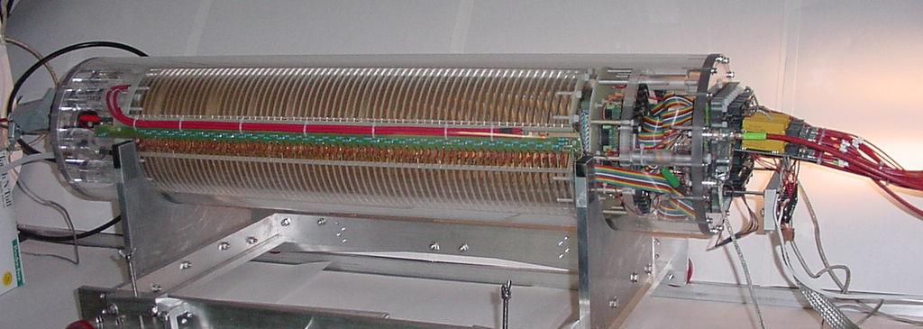
Figure 1: The Cornell/Purdue TPC

A gas-amplification device, readout pads, and readout bias distribution boards are mounted in a removable module (shown separately in figure 2b) to facilitate the measurement of many samples of various gas-amplification devices in the same TPC. In the example shown, a wire gas-amplification device is mounted to a pad array with 5mm x 10 mm pads. The readout module also supports preamplifier boards that can be seen on the far right of the photograph.

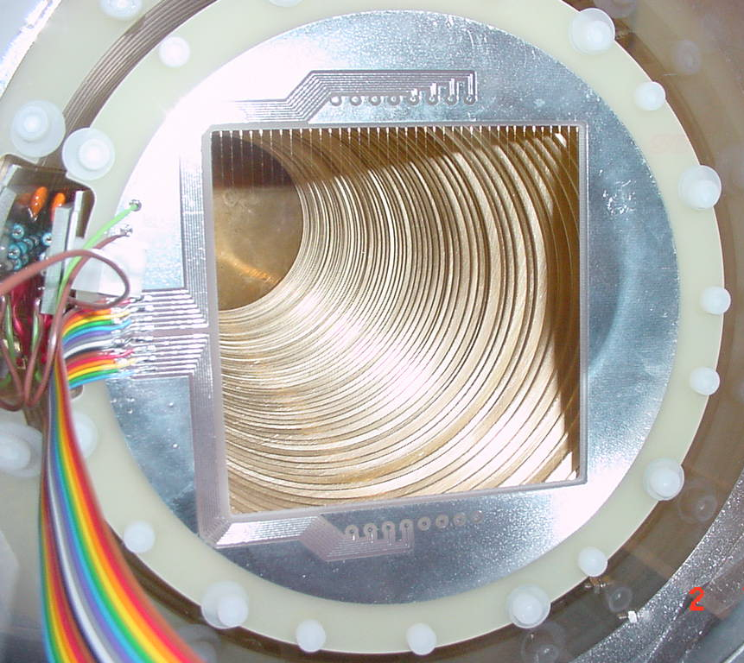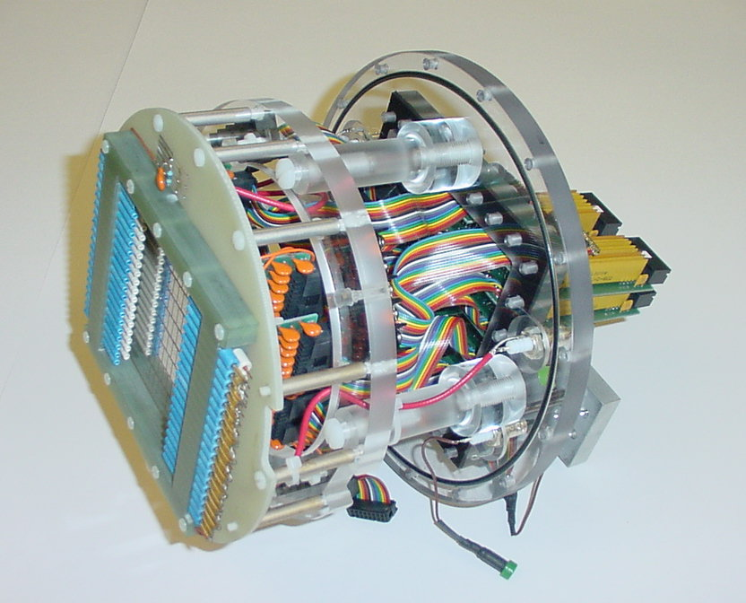
Figure 2: (a) The field cage termination plane and (b) The readout module with wire gas-amplification

Readout
Readout is through a VME-based data acquisition system. In the initial demonstration running, 32 channels were instrumented with commercial flash-ADCs. These units were chosen for high sensitivity to small signals and have 105 MHz sampling rate, +/-200 mV input range and 14 bit resolution. The pad pattern (figure 3a) has pads arranged in 7 rows for the detection of cosmic rays. There are 4 or 5 instrumented pads in each row. A sample cosmic ray event (figure 3b) shows the output of the 32 ADC channels. Vertical offsets in the display are chosen to overlay readout channels that correspond to pads in each of the 7 rows. Time, measured on the horizontal scale, spans 20 μs. In this sample event, the gas-amplification is provided by a wire array with anode-pad spacing of 5 mm and anode-pad potential difference of 2550 V. The signal from the cosmic ray is spread over 2 or 3 channels in each row.

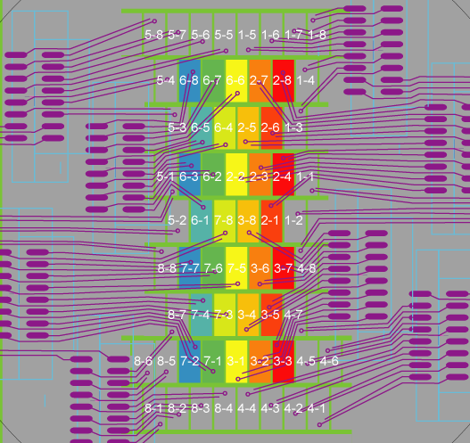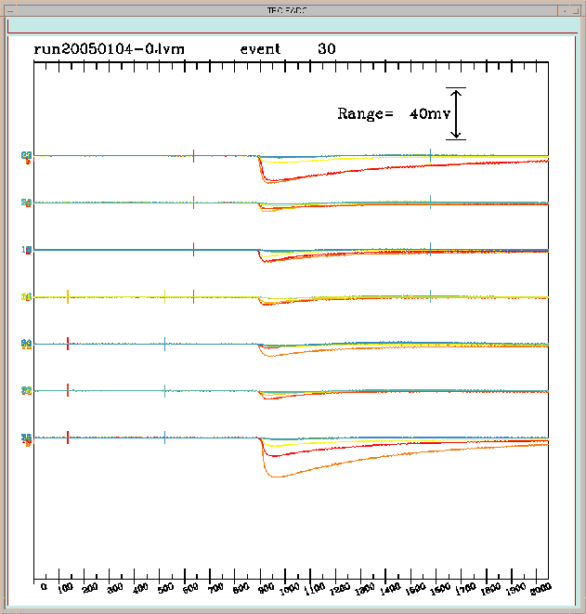
Figure 3: (a) The readout pad array and (b) Pulse height response from a cosmic ray

Measurements

Resolution measurements with the wire gas-amplification

Although the spatial resolution using 5 mm pads and wire gas-amplification can not be competitive with the resolution achievable with a MPGD gas-amplification, we make this measurement as part of demonstrating the operation of the chamber. We used Ar-CO₂ (90:10) gas with a 300 V/cm drift field. Tracks were selected by requiring time coincident signals in 6 of the 7 layers. To be included in the line fit, we further required that layers have 70% of the total pulse height contained within the maximum-pulse-height pad plus the nearest neighbors. To avoid the edges of the pad pattern, we selected events with at least 5 interior hits, i.e., hits for which the highest pulse height pad is not on the boundary of the instrumented array. We then removed, at most, one spurious hit per track. The resolution, when including the hit in the fit, under these conditions, is 900 μm for 0 to 40 cm drift.

Demonstration with single-GEM gas-amplification
Single-GEM gas-amplification was investigated after preliminary measurements with the wire gas-amplification. The CERN GEM was mounted on one of the standard readout pad boards and tested at Purdue. This assembly was then mounted in the TPC at Cornell as shown in figure 4a. The field cage termination grid was biased at -900 V. The GEM top electrode was biased at -400V and spaced 0.5 cm from the field cage termination. The GEM was operated at 400 V (bottom electrode biased at 0) to provide a gain of about 150. Finally, the pads were spaced at 3 mm from the GEM and biased at +1500 V to provide an "induction voltage" of 5 kV/cm.
A sample event is shown in figure 4b. Extracting the small signals (displayed with 1/20 the vertical scale used in figure 3b) require processing to remove common noise. In this sample event, the ADCs were configured to operate at 25 MHz; the full horizontal range is 80 μs. The output of all 32 channels was averaged to determine the common noise, which is displayed in the eighth (bottom) trace.

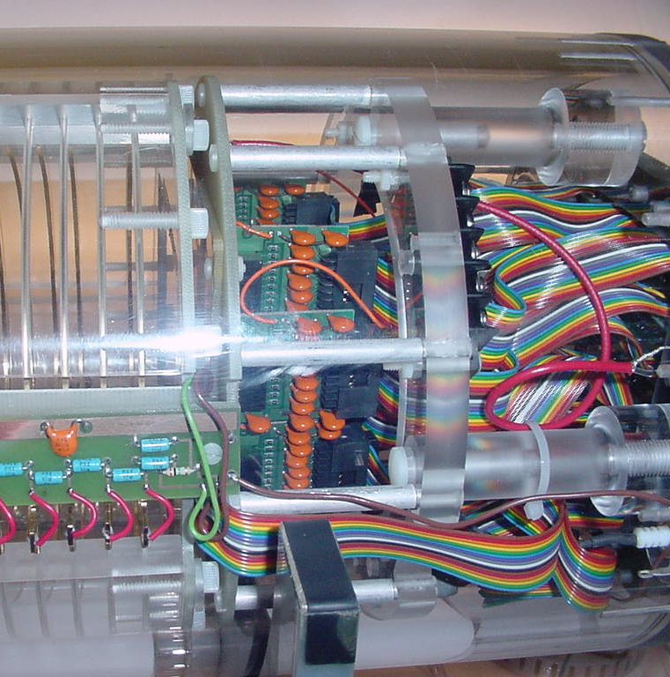
Figure 4: (a) Single GEM mounted in the TPC and (b) Cosmic ray event with single GEM gas amplification

Future Studies
After a planned expansion of the data acquisition system sufficient to instrument 2 mm pads, we expect to measure spatial resolution, reliability and positive ion feedback using multiple GEM and MicroMegas samples under common conditions. This will provide important input to the design of a TPC for an International Linear Collider detector.
Acknowledgments
This work is supported in part by the United States Department of Energy contract DE-FG02-91-ER40681 and by the United States National Science Foundation cooperative agreement NSF PHY-0202078.
References
[1] F. Sauli et al., Nucl. Instr. and Meth. A386 (1997) 531-534.
[2] I. Giomataris et al., Nucl. Instr. and Meth. A376 (1996) 29-35.
[3] see reviews by Bruce Schumm, ALCPG workshop, Victoria, 28-July-2004, http://www.linearcollider.ca:8080/lc/vic04/plenary; by Madhu Dixit, ECFA Study workshop, Durham, 1-Sept-2004, http://www.ippp.dur.ac.uk/ECFA04/; by Ron Settles, ACFA workshop, 9-Nov-2004, http://hep1.phys.ntu.edu.tw/ACFA7/; and by Jan Timmermans, these proceedings.

