APPLICATION OF COHERENT TUNE SHIFT MEASUREMENTS TO THE CHARACTERIZATION OF ELECTRON CLOUD GROWTH*

*Work supported by the US National Science Foundation PHY-0734867 and the US Department of Energy DE-FC02-08ER41538.
# dlk8@cornell.edu

# jps13@cornell.edu
#U.S. Department of Energy, and the National Science Foundation,
D.L.Kreinick#, J.A.Crittenden, G.Dugan, M.A.Palmer, G.Ramirez, CLASSE, Ithaca, NY, USA, R.L.Holtzapple, M.Randazzo, California Polytechnical State University, San Luis Obispo, CA, USA, M.A.Furman, M.Venturini, LBNL, Berkeley, CA, USA

Abstract
Measurements of coherent tune shifts at the Cornell Electron Storage Ring Test Accelerator (CesrTA) have been made for electron and positron beams under a wide variety of beam energies, bunch charge, and bunch train configurations. Comparing the observed tunes with the predictions of several electron cloud simulation programs allows the evaluation of important parameters in these models. These simulations will be used to predict the behavior of the electron cloud in damping rings for future linear colliders. We outline recent improvements to the analysis techniques which should improve the fidelity of the modeling.

1. THE METHOD
Bunch trains were set into oscillation by displacing them horizontally or vertically for one turn. We measure the turn-by-turn positions of individual bunches for typically 1024 turns, and then Fourier transform to obtain the bunch-by-bunch tunes.
Simulations are performed with POSINST[1] and compared to the measured tunes. In simulating the ring-averaged tune shifts, we ignored all ring elements except the drift regions and the dipoles, and , for the photon intensity, used the calculated number of synchrotron-radiated photons directly striking the vacuum chamber, weighted by beta values[2]. The parameters we varied in the simulation were total secondary electron yield, energy at which the yield is maximal, elastic secondary electron yield, yield of rediffused secondary electrons, quantum efficiency for photoelectron production, and the fraction of photons reflected.
Comparisons of measurements with simulations were done for 54 data runs with electron and positron beams at 1.9, 2.1, 4.0, and 5.3 GeV energy, in trains of 3 to 45 bunches, with bunch populations of 0.32 to 2.60x1010. Electron cloud buildup simulations were done and matched to the data. A reference parameter set was established based on measured secondary emission parameters for aluminum [1], and approximate estimates of quantum efficiency and photon reflectivity based on study of a single data set. All six parameters were varied ~±10% (relative to the reference parameter set) individually and in selected pairs. As an example, shown in figure 1 are data (in black) for a 21-bunch train of 0.8x1010 positrons per bunch at 2.1 GeV followed by 12 witness bunches. Three different POSINST simulations (in color) with total secondary electron yields of 1.8 , 2.0 (nominal), and 2.2 were run.
The data-simulation comparisons did not lead to a parameter set significantly improved over the refernece set because of the difficulty in finding an optimum in a 6-dimensional space when the some of the parameters are highly correlated and the error bars on the data are not reliably determined. We are now attempting to improve various aspects of the data analysis (see Section 2 below) and the simulation (see Section 3 and 4 below) so more precise determinations of the parameters will allow more relaible predictions for ILC damping ring behavior. The subsequent sections describe areas currently under development.
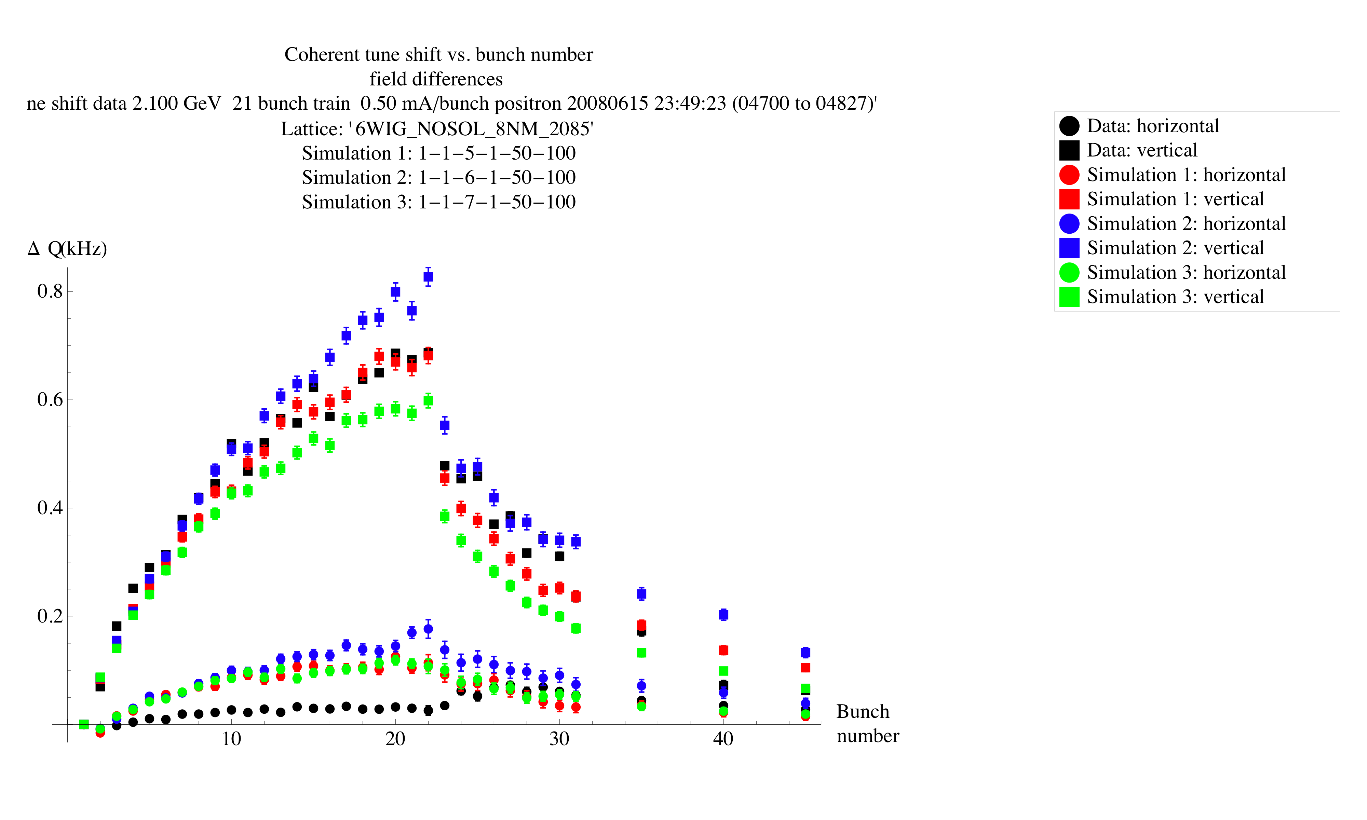Figure 1: An example of fits to data achieved with various parameters. Black dots are data, colored are simulations. The bunch current was 0.5 mA. The three different simulations (1, 2, 3) correspond to different values (2.0, 2.2, 1.8) for the total secondary yield.

2. Extracting tunes from BEAM POSTION MEASUREMENTS
Beam position measurements made under a variety of beam conditions are of varying quality. For the quantitative data/simulation comparisons needed to evaluate parameters, it is vital both to have accurate measurements and to reliably estimate their errors. New code employs a merge-sort algorithm to both improve the derived tune shifts and better assess their believability.

3. THREE_DIMENSIONAL MODELing OF synchrotron RADIATION propagation and absorption
The simulations described above use the photon intensities corresponding to the synchrotron-radiated photons directly striking the vacuum chamber, together with a single empirically determined parameter to describe the reflected photons. However, since the source of the synchrotron radiation is well known, and the reflection of the radiation from the walls can be well-characterized, it is possible to make reliable estimates of both the direct and scattered radiation. These estimates allow a full characterization of the radiation absorbed on the walls to be made, without the need for an empirically determined reflectivity parameter. Since the radiation characterization can be made for any beam energy, ring lattice, and vacuum chamber profile, this greatly facilitates the extrapolation of electron cloud buildup calculations to future positron rings.,.
A new code Synrad3D [5] has been developed to do the radiation calculations. The code uses the full three-dimensional chamber geometry and ring lattice to obtain both the intensity and the angular distribution of the synchrotron radiation hitting the chamber walls. The output of Synrad3D can be read into POSINST to provide a fully characterized description of the incident radiation. The description is limited by the accuracy of the vacuum chamber model, and by the approximations used in the scattering model. To date, the radiation calculations have been done with a simple longitudinally-uniform vacuum chamber model, and with a scattering model based on specular reflection from an aluminum surface only. However, the code has the capability to model complex vacuum chamber shapes and to include diffuse scattering.
Fig. 2 exhibits the results of a simulation using the Synrad3D radiation distributions, for the same data set as shown in Fig. 1. To improve the fit, the empirical quantum efficiency for drifts (dipoles) has been reduced by about 40% (20%) relative to the simulations shown in Fig. 1, and a Lorentizian, with parameters similar to those measured in [4], has been used for the photoelectron energy distribution (see next section). The total secondary yield was 2.0.

Figure 2: Comparison between data and a simulation with radiation distributions from Synrad3D. Black dots are data, colored are simulations.
Another example of a comparison between data, simulations using the earlier method for estimating the radiation intensity, and simulations based on Synrad3D, is shown in Fig. 3. In this case, the data correspond to self-excited tune shift measurements made in connection with beam instability measurements, as described in [6].
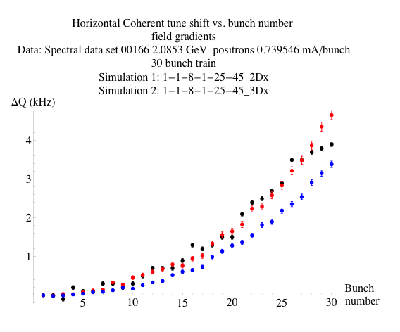
Figure 3: Comparison between data (black), simulation using direct radiation and a reflectivity parameter (red), and simulation using radiation distributions from Synrad3D (blue). Total secondary yield 2.05 in both cases.
The figure indicates that, for the Synrad3D simulation, a slightly higher value of the secondary yield is preferred.

4. QUANTUM EFFICIENCY AND photoelectron energy spectrum
In connection with studies of electron cloud effects for the LHC, direct measurements [4] have been made of the quantum efficiency, and the photoelectron energy spectrum, for VUV photons in the energy range up to about 100 eV. The measurements were made for a variety of surfaces, including aluminum, which is relevant for the CesrTA case.
The relative quantum efficiency was measured as a function of photon energy. This information can be combined with the energy spectrum of absorbed photons, which is provided by the Synrad3D code, to estimate how the quantum efficiency might be expected vary for different beam energies, and at different points in the CesrTA ring. This provides additional information that is useful in constraining electron cloud parameters when comparing with data, and in extrapolating electron cloud effects to future positron rings.
Absolute quantum efficiencies, averaged over a VUV photon energy spectrum, were also measured in reference [4]. These results were quite sensitive to the surface material and condition, but were in the range of 0.041 to 0.106. Quantum efficiency values found for the best fits to the CesrTA tune shift data are in this same range.
The measurements in reference [4] indicate that the photoelectron energy spectrum can be well represented by a Lorentzian with a peak and width of a few eV. Studies of the shielded button data as described in [5] demonstrate that, although a simple Lorenzian distribution is adequate for the photons generated by a 2 GeV CesrTA beam, for the harder photon spectrum generated by a 5 GeV beam, a high energy tail, with a power law falloff slower than that of a Lorentzian, is required. Consequently, a new parameterization, using a Lorentzian, spliced to a power law distribution with an adjustable exponent at high photoelectron energies, has been installed in POSINST.. Preliminary reevaluation of the tune shift simulations for both positron and electron beams at 5 GeV indicate that the high energy tail in the photoelectron energy spectrum makes only a small differences in the simulated tune shifts.

5. MEASUREMENTS UNDER DIFFERENT CONDITIONS
Most of the data taken to were taken with 14 ns spacing between bunches. An exception is shown in Fig. 4.

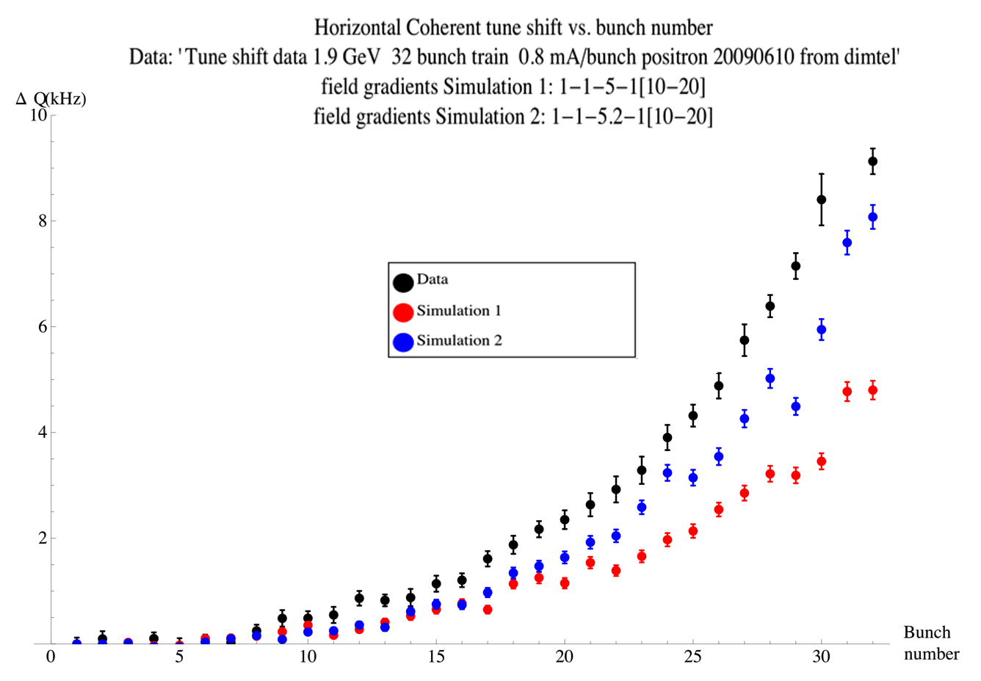
This data set corresponds to a 32 bunch train with 4 ns spacing. The data were taken using the Dimtel feedback system, as discussed in [6]. They seem to favor a higher total secondary yield than most of the 14 ns data.
Clearly, to separate the effects of primary photoelectrons from those of secondaries, it is very useful to study a variety of bunch spacings. Additional data have been taken with 4-, 8-, 12-, and 16-ns spacing, but unfortunately, the results have proven difficult to interpret. It is hoped that the more advanced analysis techniques mentioned in Section 2 will allow us to interpret these data. Otherwise, new measurements will need to be taken.

References
[1] M. Furman and G. Lambertson, “The electron-cloud instability in the arcs of the PEP-II positron ring,” http://repositories.cdlib.org/lbnl/LBNL-41123.
M. A. Furman and M. T. F. Pivi, Probabilistic Model for the Simulation of Secondary Electron Emission, Phys. Rev. ST-AB 5, 124404 (2002).
[2] G. F. Dugan, M. A. Palmer, and D. L. Rubin, ILC Damping Rings R&D at CesrTA, ICFA Beam Dynamics Newsletter No. 50, eds. J. Urakawa and W. Chou (2009).
J. A. Crittenden, et al., Studies of the Effects of Electron Cloud Formation on Beam Dynamics at CesrTA, proceedings of PAC09, 4-8 May 2009, Vancouver, British Columbia, Canada.
[3] G. Dugan, S. Milashuk, D. Sagan, "Synrad3D Photon propagation and scattering simulation", ECLOUD10 workshop.
[4] Cimino, Collins, Baglin, VUV photoemission studies of candidate LHC vacuum chamber materials, PRSTAB 2,063201 (1999)
[5] J. Crittenden et. al., contribution to this conference
[6] M. Billing et. Al., “Measurement Techniques to Characterize Instabilities caused by Electron Clouds,”, contribution to this conference.

Figure. 4: Comparison between data (black), and 2 simulations using direct radiation and a reflectivity parameter (red). Total secondary yield 2.0 (simulation 1) and 2.2 (simulation 2).

