Physics 4410/6510
Experiment Z-1
Charged Particle Beam

Experimental Procedure

Ion Optics
In this section you will measure the variation in the image magnification as the Einzel lens voltages (Φ₁ and Φ₂) and the extractor voltage are varied.
- Before you begin you must determine the calibration of both of the Einzel lenses’ voltages and the Extractor’s voltage. As both of these power supplies output very large voltages, you must use a voltage divider and voltmeter. Plot the voltage measured using the voltage divider versus the voltage read off each power supply gauge.

- Set Φ₁= 0 V. While looking at the second screen, adjust Φ₂until the image comes into focus. You know that your image is focused when you can see a number of “dots.” These are images of each of the grid points. A focused image is shown in Fig.1.

- Now, vary Φ₁ and observe how the shape and size of the image changes. Take a picture of the screen for a few Φ₁ values. Determine the magnification of each image based on the size of the viewing screen, the size of the grid and the 45° angle between the screen and the viewing window.

Note: A good method for taking a picture of the beam is to mount the camera above the viewing window and cover the lens with black paper.

- Repeat this process for different extractor voltages and gases.

- Compare your results to ion optics theory. You may find it helpful to use an ion optics simulation program such as SIMION to do this.
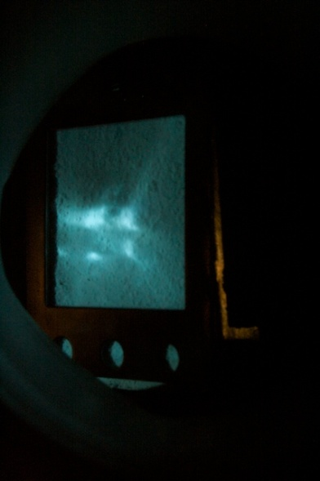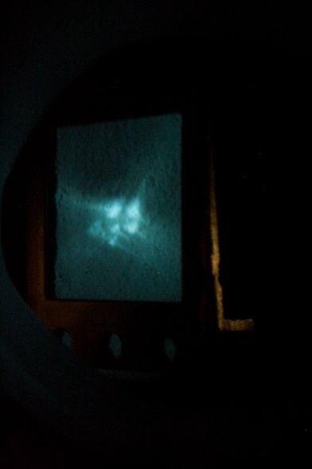
Figure 1. Focused image on second screen. Right and left photos show different magnifications.

Mass Spectrometry
- Begin by inserting the Gauss meter probe in between the magnet’s plates as seen in Fig. 2. (Be very careful with the probes as they are very expensive!)

Note: if you do not have a Gauss meter, ask to borrow one from another experiment. You can use a multi-meter connected to the back of the power supply to determine how the voltage is related to the magnetic field.

- Attach the ammeter to the Faraday cup at the end of the beam line.
- Vary the voltage of the magnet’s power supply recording the changes in the current from the ammeter.
- Determine the mass-to-charge ratio associated with each current peak. (Bending radius of the magnet is 8 inches).

Note: the third viewing screen can be used to determine the approximate position of the peaks.
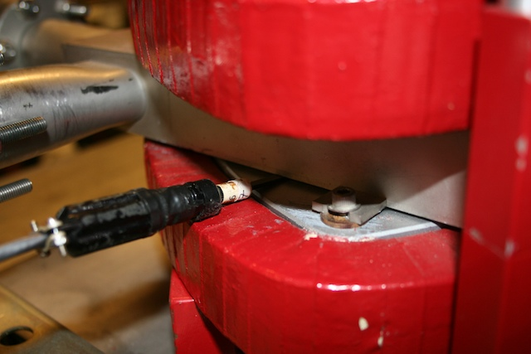
Figure 2. Gauss meter probe inserted in between magnet's plates.
References
- P. Grivet, M.Y. Bernard, F. Bertein, R. Castaing, M. Gauzit and A.
Septier, “Electron Optics”, Second English Edition, Pergamon Press, 1972. pp. 85-96, 211-220, 815-829

- “Focusing of Charged Particles”, Edited by A. Septier. Chapter 2.2.
- P. Dahl, “Introduction to electron and ion optics”, New York, Academic Press, 1973. pp. 127-131

